Year Project A.

User Manual for WD-PIC

26/01/98

Students:
Full Name | ID Number | E-mail
Alishaev Mark | 310745351 | suprmark@t2.technion.ac.il
Kakuzin Vitali | 310428867 | c1042886@t2.technion.ac.il
Kofman Vladimir | 310692736 | c1069273@t2.technion.ac.il

Contents

How the UI is look like………………………………………………….3-4

Menus……….………..…………………...……………………………….5

Managing files….….....………………..………………….……………….6

Drawing……..………..………………………………………………….7-8

Inserting structures , files…...……..……………………………………….8

Changing properties of element…………………………………………….8

Edit advanced options…….………… …………………………………….9

General advanced options ……………………………………………….9-10

Using right mouse button………………………..………………………….10
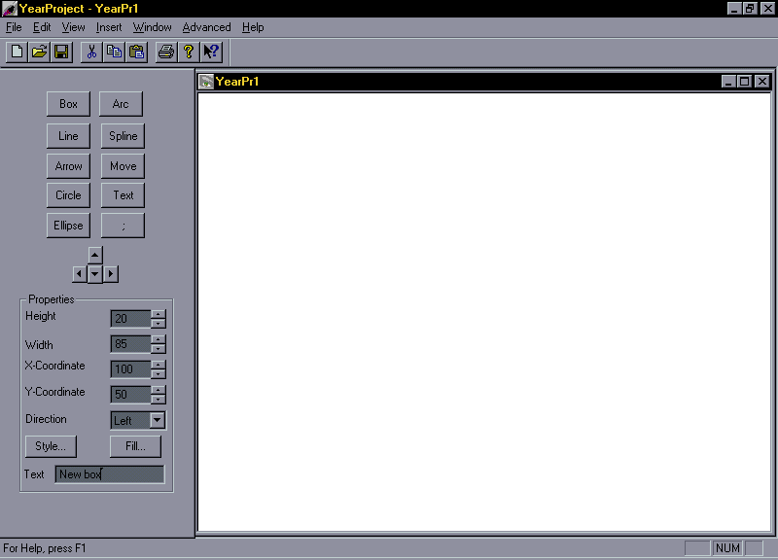

WD-PIC starts up with the main window shown above.
There are three parts in the main window:
- The Personal Toolbar in the left part of the main window(the look is when currently box element selected)
- The menu bar
- The toolbar bellow the menu bar
- The drawing area with vertical and horizontal scrollbars , used to reveal additional parts of the drawing area

The Personal toolbar is divided into three parts:
- Pic tokens
- Drawing directions
- When some element selected or new one created at the bootom half of the toolbar will rise dialog with element’s attributes(properties)
The menus:
The menu bar contains 7 popup menus:
- File
- Edit
- View
- Insert
- Window
- Advanced
- Help

File popup menu:
The File popup menu has the following items: New , Open , Close , Save , Save As , Print , Print preview ,
Print setup , Recent files , Exit .

Edit popup menu:
The Edit popup menu has the following items: Undo,Redo,Cut,Copy,Paste .

View popup menu:
The View popup menu has the following items: Toolbar , Status bar , Personal toolbar ,
File source , Element’s properties .

Insert popup menu:
The Insert popup menu has the following items: Box , Ellipse , Circle , Line , Spline , Arc ,Arrow,
Structures popup menu , Insert new file… .
Structures popup menu has the following items: if…then…else , for .

Window popup menu:
The Window popup menu has the following items: New Window , Cascade , Title , Arrange Icons &
List of currently opened windows.

Advanced popup menu:
The advanced popup menu has the following items: Change defaults , Save defaults , Load defaults , Reset defaults .

Help popup menu:
The help popup menu has the following items: Index , Contents , About .
Managing files:
1) Creating a new picture: to create a new picture you should go to ‘File’ menu and choose ‘New’ option or you simply press
'Ctrl+N’ keys on the keyboard.

Or you can choose the next option of the toolbar:
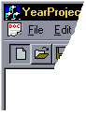
2) Opening an existing picture: to open an existing picture you should go to ‘File’ menu and choose ‘Open’ option or you simply
press ‘Ctrl+O’ keys on the keyboard.

Or you can choose the next option of the toolbar:
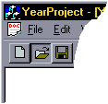
3) Saving currently opened picture: to save currently opened picture you should go to ‘File’ menu and choose ‘Save’ option or you
simply press ‘Ctrl+S’ keys on the keyboard.
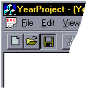Or you can choose the next option of the toolbar:

Drawing:
Box:
To insert a box you have 2 options:

- Type the next sequence of letters: ‘b’ ‘o’ ‘x’ .
- Choose “Insert->Box…” option from the menu bar .

The default box will be drawn and the following dialog will rise:
????????????????????

Ellipse:
To insert an ellipse you have 2 options:

- Type the next sequence of letters: ‘e’ ‘l’ ‘l’ ‘i’ ‘p’ ‘s’ ‘e’ .
- Choose “Insert->Ellipse…” option from the menu bar .

The default ellipse will be drawn and the following dialog will rise:
????????????????????

Circle:
To insert a circle you have 2 options:

- Type the next sequence of letters: ‘c’ ‘i’ ‘r’ ‘c’ ‘l’ ‘e’ .
- Choose “Insert->Circle…” option from the menu bar .

The default circle will be drawn and the following dialog will rise:
????????????????????

Line:
To insert a line you have 2 options:

- Type the next sequence of letters: ‘l’ ‘i’ ‘n’ ‘e’ .
- Choose “Insert->Line…” option from the menu bar .

The default line will be drawn and the following dialog will rise:
????????????????????

Spline:
To insert a spline you have 2 options:

- Type the next sequence of letters: ‘s’ ‘p’ ‘l’ ‘i’ ‘n’ ‘e’ .
- Choose “Insert->Spline…” option from the menu bar .

The default spline will be drawn and the following dialog will rise:
????????????????????

Arrow:
To insert an arrow you have 2 options:

- Type the next sequence of letters: ‘a’ ‘r’ ‘r’ ‘o’ ‘w’.
- Choose “Insert->Arrow…” option from the menu bar .

The default arrow will be drawn and the following dialog will rise:
????????????????????

Arc:
To insert an arc you have 2 options:

- Type the next sequence of letters: ‘a’ ‘r’ ‘c’ .
- Choose “Insert->Arc…” option from the menu bar .

The default arc will be drawn and the following dialog will rise:
????????????????????

Standalone text:
To insert a standalone text you have 2 options:

- Type the next sequence of letters: ‘t’ ‘e’ ‘x’ ‘t’ .
- Choose “Insert->Text…” option from the menu bar .

The default standalone text will be drawn and the following dialog will rise:
????????????????????

Inserting structures :
WD-PIC provides the possibility of using Pic if statements and for loops.

If statement:
To insert the if statement you have 2 options:

- Type the next sequence of letters: ‘i’ ‘f’ .
- Choose “Insert->Structures->if…then…else’ option from the menu bar .

The “if” statement will be inserted to the pic file.

For loop:
To insert the for loop you have 2 options:

- Type the next sequence of letters: ‘f’ ‘o’ ‘r’ .
- Choose “Insert->Structures->for’ option from the menu bar .

The “for” loop will be inserted to the pic file.

Inserting files :
WD-PIC provides the possibility to insert an existing PIC file to currently opened file.

To do that you have 2 options:

- Right-click mouse and choose ‘Insert file’ option .
- Choose “Insert->Insert file…’ option from the menu bar .

The regular ‘Open file’ dialog will rise after choosing file and clicking on the place , that you want to insert the file the contents of choosed file will appear .

Changing properties of element :
The program allows you to change the attributes of selected element(first you have to select the element):

To do that you have 3 options:
- Right-click mouse and choose ‘Properties’ option
- Double-click the element .
- Choose ‘View->Element’s properties…’ from the menu bar.

The properties dialog(different for each element) will appear at bottom half of the personal toolbar .

To change the element’s size you also can drag the sides of the selected element .
To change the element’s place you can drag the whole element.

Viewing the PIC source of the file :
The program allows you to view the PIC source currently edited file.

Just choose ‘View->File source’ from the menu bar .

Edit advanced options:
There are 5 advanced ‘edit’ options : Undo , Redo , Cut , Copy and Paste .
Undo: Just choose ‘Edit->Undo’ option from the menu bar or right-click mouse and choose ‘Undo’ option .
Redo: Just choose ‘Edit->Redo’ option from the menu bar or right-click mouse and choose ‘Redo’ option .

Cut: Select the element that you want to cut & choose ‘Edit->Cut’ option from the menu bar or right-click
mouse and choose ‘Cut’ .

Copy: Select the element that you want to cut & choose ‘Edit->Copy’ option from the menu bar or right-click
mouse and choose ‘Copy’ .

Paste: Before doing that you have to ‘cut’ or ‘copy’ some element & choose ‘Edit->Paste’ option from the menu

bar or right-click mouse and choose ‘Paste’ .

Advanced options of WD-PIC:

Changing the defaults for each element:
After choosing this option, you’ll get next dialog:
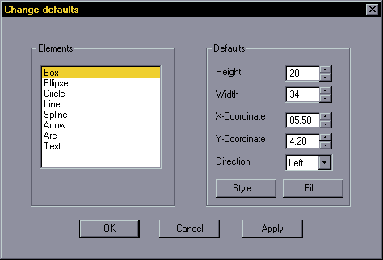
At the left side of the window you can choose the element and accordingly to this, at the left side you can change the defaults for this element (at the example above we choose ‘Box’ element).

Saving the defaults to file:
Also you have option to save current configuration of defaults to file, just choose “Advanced->Save defaults…”:
Loading the defaults from file:
Also you have option to restore configuration of defaults from file, just choose “Advanced->Load defaults…”
Resetting the defaults :
Also you have option to reset the defaults , just choose “Advanced->Reset defaults…”
Changing the scale:
Also you have option to change the scaling, just choose “Advanced->Change scale…”

Using the right mouse button:
When you right-click on empty place at the picture you’ll get the following popup menu:
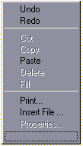

- You can ‘Undo’ your last action.
- You can ‘Redo’ your last ‘Undo’ action.
- You can Paste last ‘cutted’ or ‘copied’ item from the clipboard
- You can ‘Print’ the hole picture
- You can ‘Insert File’ into the current picture

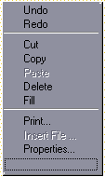When you right-click on some element at the picture you’ll get the following popup menu:

- You can ‘Undo’ your last action.
- You can ‘Redo’ your last ‘Undo’ action.
- You can ‘Cut’ the element into clipboard
- You can ‘Copy’ the element into clipboard
- You can check and change the properties of current element.

