Blah blah blah

Blah blah blah

Blah blah blah

Blah blah blah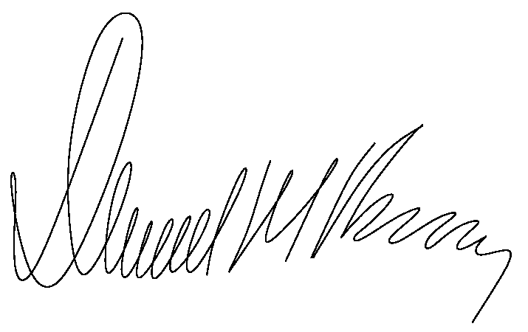

Blah blah blah

Blah blah blah

Blah blah blah

Blah blah blah

Blah blah blah

Blah blah blah

Blah blah blah

Blah blah blah

Blah blah blah

Blah blah blah

Blah blah blah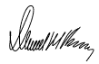

Blah blah blah

Blah blah blah

Blah blah blah

Blah blah blah

Blah blah blah

Blah blah blah

Blah blah blah

Blah blah blah

Blah blah blah

Blah blah blah

Blah blah blah

Blah blah blah

Blah blah blah

Blah blah blah

Blah blah blah

Blah blah blah

Blah blah blah

Blah blah blah

Blah blah blah

Blah blah blah

Blah blah blah

Blah blah blah

Blah blah blah

Blah blah blah

Blah blah blah

Blah blah blah

Blah blah blah

Blah blah blah

Blah blah blah

Blah blah blah

Blah blah blah

Blah blah blah

Blah blah blah

Blah blah blah

Blah blah blah

Blah blah blah

Blah blah blah

Blah blah blah

Blah blah blah

Blah blah blah

Blah blah blah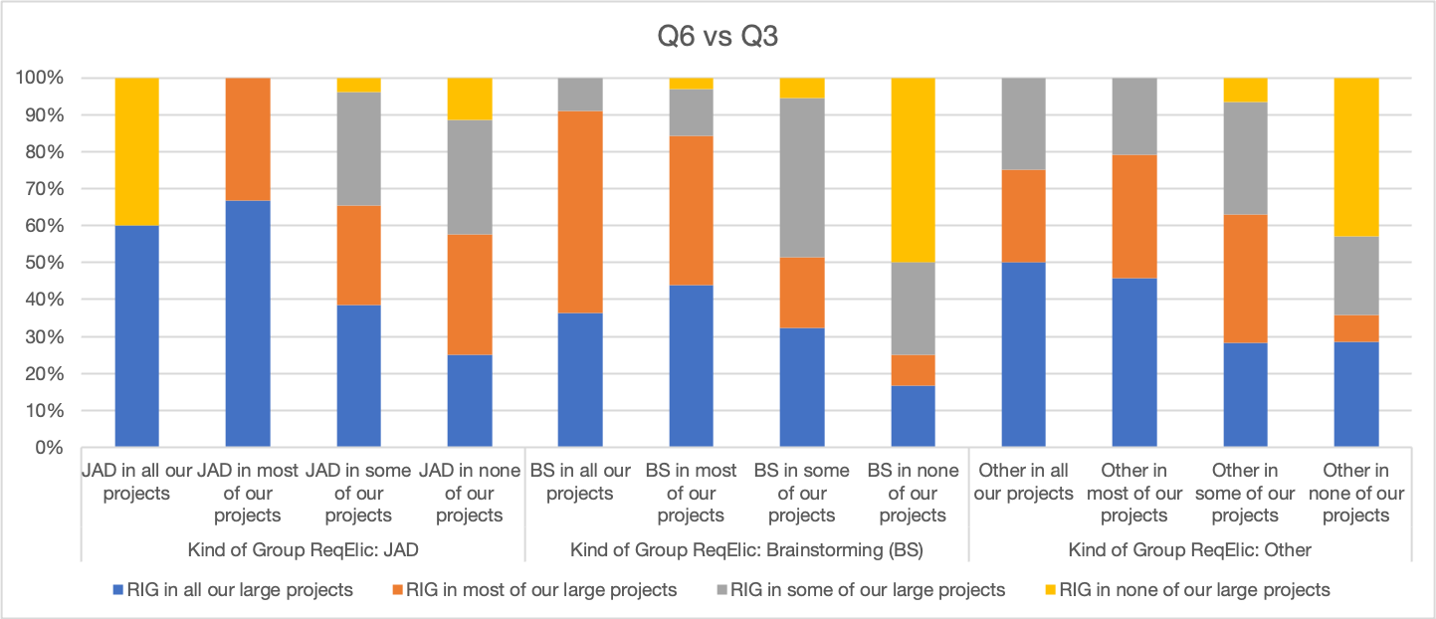

Blah blah blah

Blah blah blah

Blah blah blah

Blah blah blah

Blah blah blah

Blah blah blah

Blah blah blah

Blah blah blah

Blah blah blah

Blah blah blah

Blah blah blah

Blah blah blah

Blah blah blah

Blah blah blah

Blah blah blah

Blah blah blah

Blah blah blah

Blah blah blah

Blah blah blah

Blah blah blah

Blah blah blah

Blah blah blah

Blah blah blah