Book Review of The Chrysanthemum and the Sword
The book, The Chrysanthemum and the Sword by the American anthropologist Ruth Benedict was published in 1946 as a response to the invitation of the U.S Office of War Information to understand and predict the behaviour of Japanese in World War II (Vogel, 1989). The response to the book has been enormous, especially in Asia. In Japan, the book has attracted a large amount of audience and has generated a large amount of commentary. According to Professor Nakano Fukui, the Japanese version of The Chrysanthemum and the Sword has sold over 2,300,000 copies (Kent, 1999). However, the validity of Benedict’s research has always been questioned. Ruth Benedict says in her book:
I could not go to Japan and live in their homes and watch the strains and stresses of daily life, see with my own eyes which were crucial, and which were not. I could not watch them in the complicated business of arriving at a decision. I could not see their children being brought up. (Benedict, 2006)
It is worth noticing that Benedict did not conduct a primary research. The primary source of information she is using is Japanese who live in the United States and other articles that are written by Westerners who had lived in Japan. As a result, some argue that the biased information may contaminate the book.
In the first 10 Chapters, Benedict analyzes the reason behind the duality of the characteristic of Japanese, the foundational forming of Japanese society, and the different perspective regarding life and values. Some interesting aspects of Japan will be discussed below.
Before discussing the details about the Japanese people during the WW II, it is necessary to get a general idea about the special circumstances of the background of the period. In the 1930s, the whole capitalist world suffers from the Great Depression. It was a severe economic depression that almost destroyed the capitalist system. Two paths were used for different countries to recover from the Great Depression, one is the reform within the capitalist system. One well-known example is the New Deal proposed by President Franklin D. Roosevelt. Another path is to form a fascist government, examples are Benito Mussolini from Italy and Adolf Hitler from Nazi Germany. To cut unemployment, American government creates public construction jobs by working on a wide range of infrastructure including bridges, airports, dams and so on while fascist government actively building up its military forces and building military factories. The common core between these two paths is the increasing of government intervention of economy. The situation is similar in Japan. Japanese economy also cripples during the 1930-31 period as a consequence of the Great Depression (Shizume, 2009). The conflict between Tōseiha (統制派) and Kōdōha (皇道派) eventually intensified into the February 26 Incident (二・二六事件). February 26 Incident is the milestone of the Japanese fascist movement.
An interesting aspect is that Japan promotes its own idea of country hierarchy that is similar to the Imperial Chinese Tributary System (中华朝贡体系). In 1938, Konoe Fumimaro (近衞 文麿), the Prime Minister of Japan announce a statement called Toa Shin Chitsujo (東亜新秩序) to rationalize the invasion of China, which later became “Great East Asia Co-Prosperity Sphere” (Daitōa kyōeiken 大東亜共栄圏). (Britannica Japan Co., Ltd., 2014). Benedict says in her book:
Japan saw the cause of the war in another light. There was anarchy in the world as long as every nation had absolute sovereignty; it was necessary for her to fight to establish a hierarchy under Japan, of course, since she alone represented a nation truly hierarchal from top to bottom and hence understood the necessity of taking 'one's proper place.' Japan, having attained unification and peace in her homeland, having put down banditry and built up roads and electric power and steel industries, having, according to her official figures, educated 99.5 per cent of her rising generation in her public schools, should, according to Japanese premises of hierarchy, raise her backward younger brother China. Being of the same race as Greater East Asia, she should eliminate the United States, and after her Britain and Russia, from that part of the world and 'take her proper place.' (Benedict, 2006)
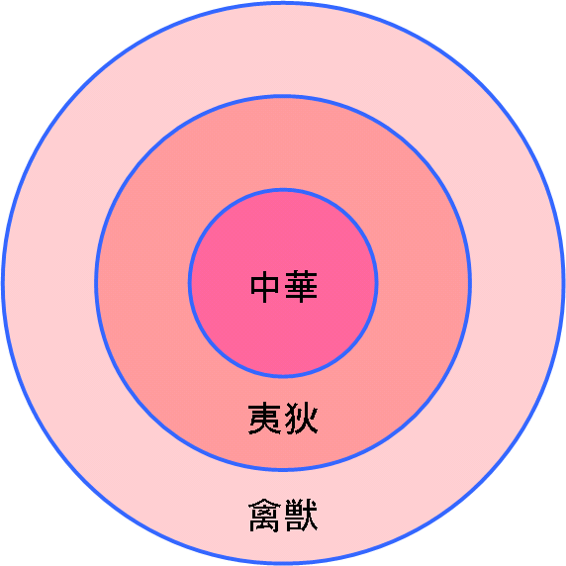
Figure 1 A illustration of the notion of Sinocentrism.
by Inulab [Public domain or Public domain], from Wikimedia Commons, Retrieved from https://commons.wikimedia.org/wiki/File:%E4%B8%AD%E8%8F%AF%E6%80%9D%E6%83%B3.PNG
It can clearly see from the cited paragraph that Japan wants to create a similar tributary system like China. After the Meiji Restoration, the westernized Japan is superior in terms of military, education and economy. It makes Japan believe that the center of the oriental world should shift to Japan. As the leader of the oriental world, Japan could and should help out East Asian countries away from the barbarians (the United States, Britain, and Russia) to create its new world order. It is a direct result of the deep influence of Confucianism in Japan. China used to believe that China is superior as China possesses the advanced civilization and technology and it is the duty of China to enlighten the surrounding countries. The idea of the Great East Asian Prosperity Sphere is a continuation of the tributary system in some sense. If Japan had successfully maintained its domination in East Asia, a similar system like the tributary system is expected.
Ruth Benedict also mentioned an interesting aspect of Japanese culture, the On (恩) culture: “They are debtors to the ages” (Benedict, 2006). Oriental countries think themselves to be the debtors of history and society, individual wills and actions should come from the feeling of indebtedness. It is not only Japan, China also has the similar culture. One famous quote from the famous Confucianist Zhang Zai is “To ordain conscience for Heaven and Earth. To secure life and fortune for the people. To continue lost teachings for past sages. To establish peace for all future generations.” (为天地立心，为生民立命，为往圣继绝学，为万世开太平。) It is expected that a scholar should carry the mission of Confucius. In Japan, “On” is used to confirm everyone’s position in a giant mingled network of “On”. It includes the “On” from the ancestors, Imperial Family and people in the same era. The first and biggest “On” comes from the Emperor of Japan. Everyone should be very grateful when receiving “On” from the Emperor of Japan. One example given in the book is that
Every cigarette distributed to the Army on the front lines in the Emperor's name during the war underscored the on each soldier wore for him; every sip of sake doled out to them before going into battle was a further Imperial on. Every kamikaze pilot of a suicide plane was, they said, repaying his Imperial on; (Benedict, 2006)
Once “On” is received, one is expected to pay off the “On”. Thus, Japanese people would avoid getting entangled in the consequence of “On”. One specific example can be drawn from the Japanese language. In Japanese, “Kino doku” (気の毒) is used to express the feeling of apologetic by troubling others (他人に迷惑をかけて申し訳なく思うこと) (Matsumura). The literal translation of “Kino doku” is the poisonous feeling. By receiving your “On”, you are making me uncomfortable. There are many ways of expressing the idea of “Thank you”. One of the phrases is “Arigato” (ありがとう). The phrase originated from an adjective “Arigatashi” (有り難し), which means the existing thing is difficult. (「有る（ある）こと」が「難い（かたい）」) (Lookvise, Inc.) Another common word like “Kino doku” is “Sumimasen” (すみません), which is the conjugate of “Sumu” (済む). “Sumu” means “to finish”, “Sumimasen” is the negative form of “Sumu”. The literal translation is “This does not end.”. From the ways of expressing gratefulness, it can be seen that it is an obligation that you pay back “On” once you receive benefits from others. Once you received “On”, it has become a constant debt and one is expected to pay off the “On” proactively.
There are many different interesting aspects of Japanese culture being discussed in the book, The Chrysanthemum and the Sword. However, due to the limitation of this book review, it is impractical to examine all of them. It is better to cherry-pick the most attracting aspects to me.
In the future, Japanese action is heavily dependent on external circumstances. Japan will closely watch whether militarism has also failed in other nations or not. If militarism succeeded elsewhere, Japan might reignite its warlike ardor. If militarism failed, Japan will prove to other countries that militarism is not the path to honor.

Bibliography
Benedict, R. (2006). The Chrysanthemum and the Sword. Mariner Books. Retrieved from http://gen.lib.rus.ec/book/index.php?md5=BF0E8DE3D838DEFBE6ADAD793E42FC7F
Britannica Japan Co., Ltd. (2014). ブリタニカ国際大百科事典. Britannica Japan Co., Ltd. Retrieved from コトバンク: https://kotobank.jp/word/%E6%9D%B1%E4%BA%9C%E6%96%B0%E7%A7%A9%E5%BA%8F-103035
Kent, P. (1999). JAPANESE PERCEPTIONS OF "THE CHRYSANTHEMUM AND THE SWORD. Dialectical Anthropology, 24(2), pp. 181-192. Retrieved from http://www.jstor.org/stable/29790600
Lookvise, Inc. (n.d.). 有難う（ありがとう） - 語源由来辞典. Retrieved from 語源由来辞典: http://gogen-allguide.com/a/arigatou.html
Matsumura, A. (n.d.). デジタル大辞泉. Japan: Shogakukan Inc. Retrieved from https://kotobank.jp/word/%E6%B0%97%E3%81%AE%E6%AF%92-475271
Shizume, M. (2009, May). The Japanese Economy during the Interwar Period: Instability in the Financial System and the Impact of the World Depression. Bank of Japan Review. Retrieved from https://www.boj.or.jp/en/research/wps_rev/rev_2009/data/rev09e02.pdf
Vogel, E. F. (1989). The Chrysanthemum and the Sword. Boston: Houghton Mifflin.

