To use Exchange Calendars in Thunderbird you need to make sure you have the newest version of Thunderbird
Thunderbird includes an add-on called Lightning that allows Thunderbird to work with the Exchange Inbox.
To check you add-ons you need to go to the Add-on page
Click on the “hamburger menu” to the right of the Search Box and select Add-ons
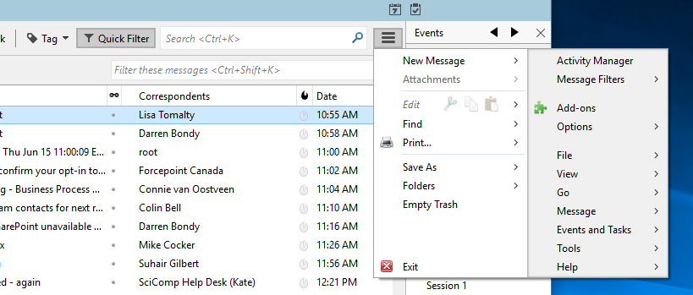
You will see your active Add-ons
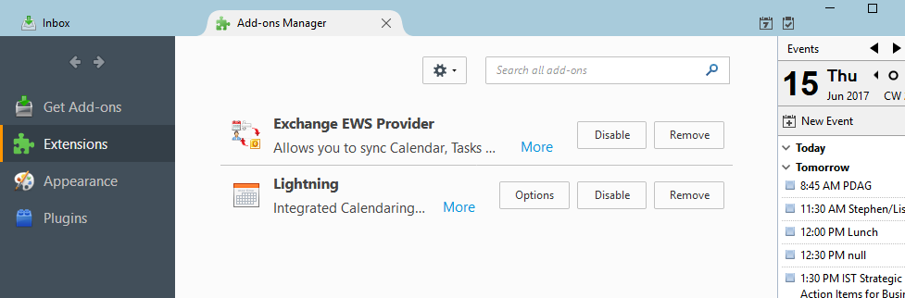
Lightning should be installed.
The Exchange EWS Provider add-on is required to connect to Exchange Calendars. It is not in the official Mozilla Downloads so you need to download it from the developer.
We need Exchange EWS Provider 4.0.1002 or newer to work with Exchange 2016. The file I downloaded is here:
http://www.acfd.cz/exchangecalendar-4.0.1003.xpi
Once you download the file, in Thunderbird on the Add-ons page look for the gear icon to the left of the Search Box. Click the icon and select the option: Install “Add-on From File…”
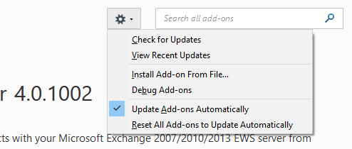
Browse to where your copy of Exchange EWS Provider 4.0.1003. Double-click the file name to begin importing the Add-on
You will be prompted to Install the Add-on - Click Install
After the Install – restart Thunderbird
Go to the Calendar page by clicking on the hamburger menu to the right of the Search Box and selecting Events and Tasks and then selecting Calendar
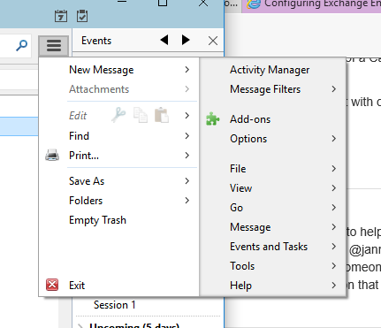
In the left side area under the word Calendar right click and select New Calendar
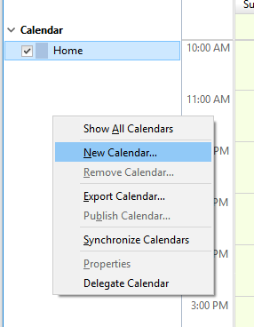
Select On the Network and click NEXT
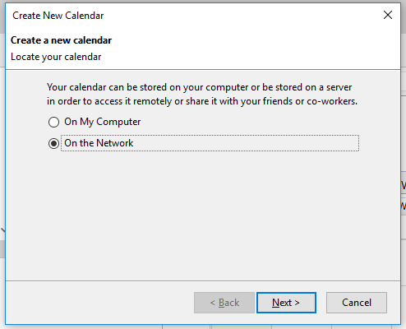
Select the Microsoft Exchange option. Do not change the Location it displays and click NEXT
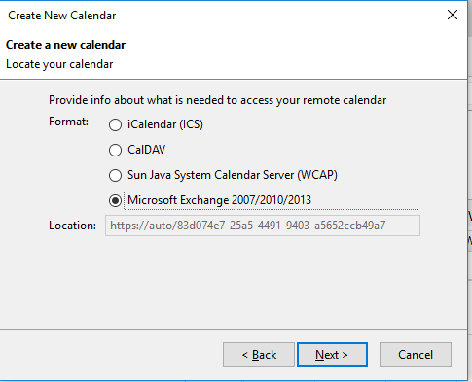
Give your Calendar a Name
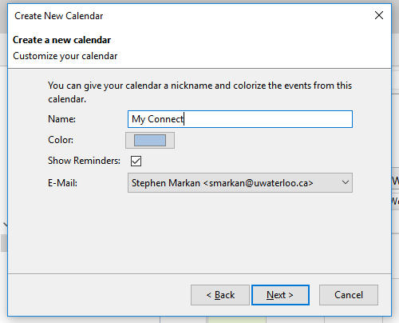
In the new Windows make sure you Select Hosted Exchange
The check the Use Exchange’s autodiscovery function
Fill in the username (your username) and the Domain name as Nexus
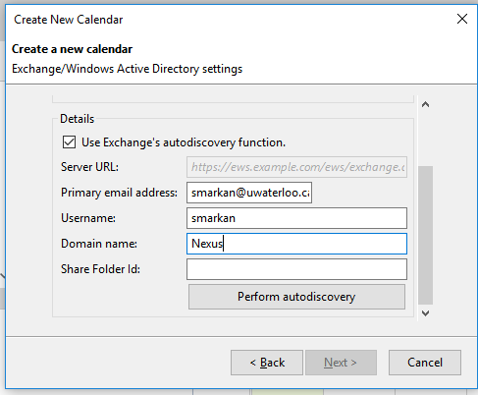
Click on the Perform autodiscovery button
If prompted enter your password and check the Use Password manager option
After you enter your password you will see – leave as displayed!
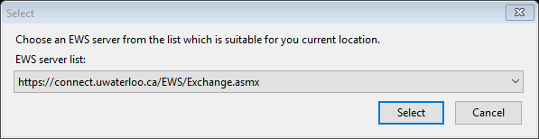
You may be prompted for your password again – enter and check “use Password Manager…” then click OK
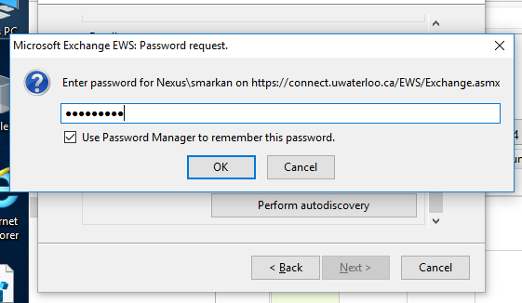

It will return a windows to select what you are connecting – by default it will be the Calendar Folder. If you want another service you can select Tasks or your Contacts. Leave it at Calendar and select Next, the Click Finish
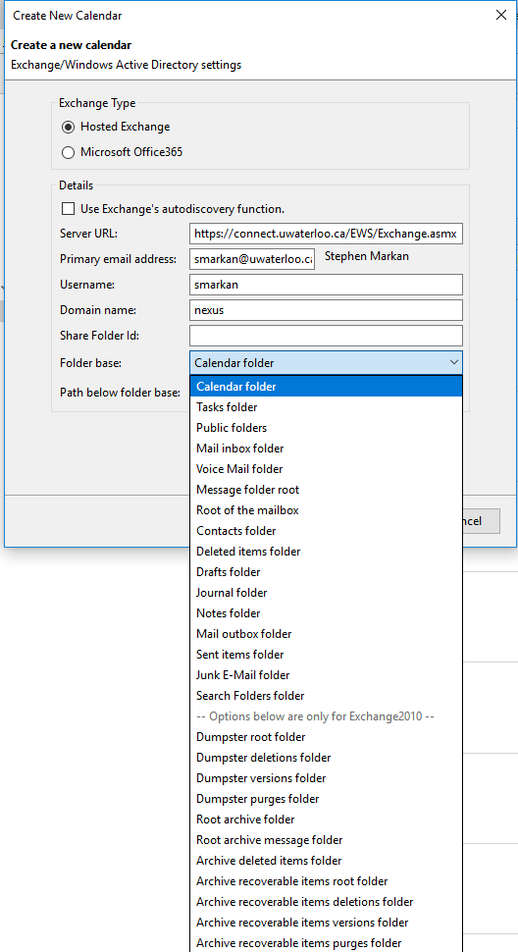
Give the server a few minutes to synchronize your calendar to Thunderbird
Now you will see your events on your main page
