HOW TO INSTALL RICOH PRINTER DRIVERS ON MAC

- Locate the Ricoh printer drivers that were downloaded on your computer
  - To install the driver, double-click on the driver

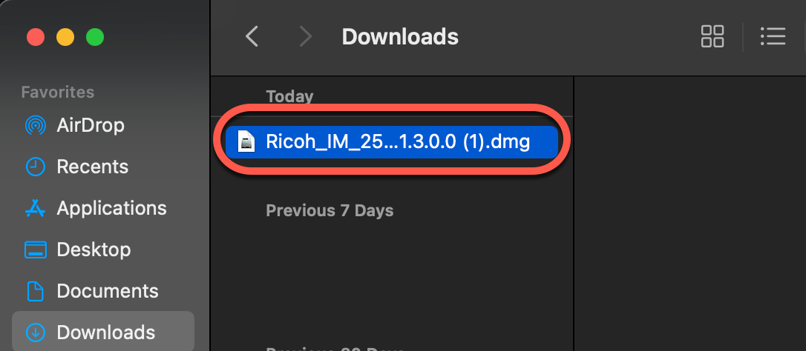

- A new window will open
  - Double-click the driver icon that looks like an Open box

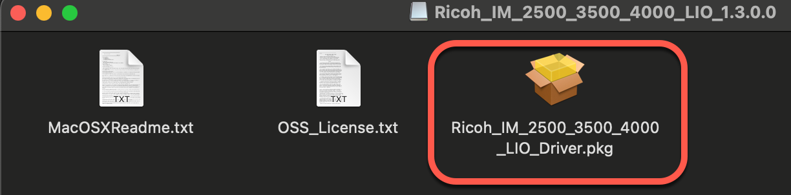

- After double-clicking on the installation icon. A new Install window will open
  - Click Continue

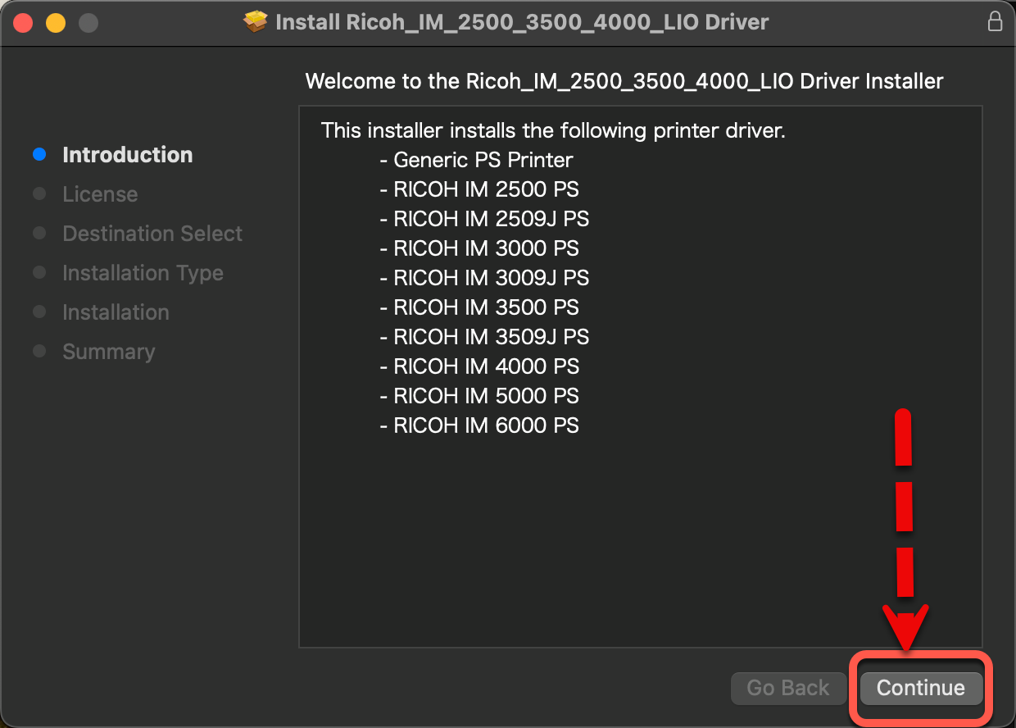

  - Software License Agreement
    - Click Continue

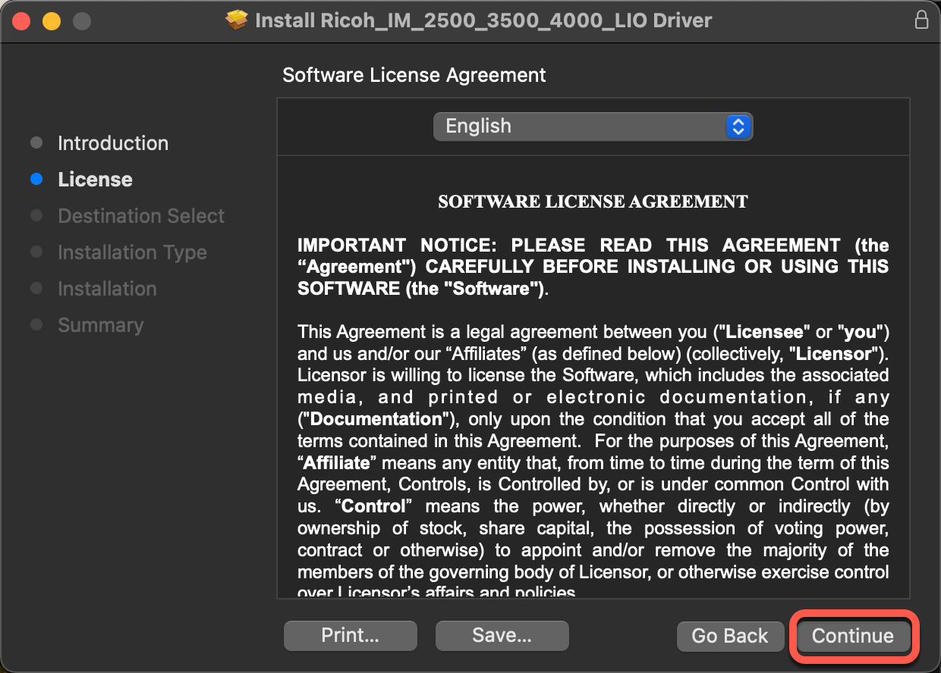

  - On the next window. Click on Agree

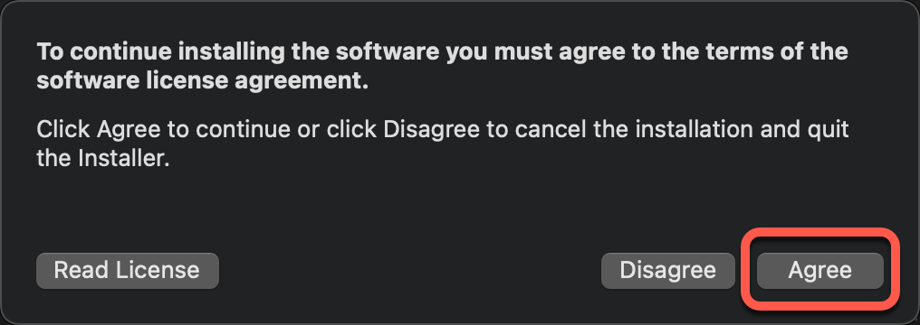

  - On the next window. Click Install

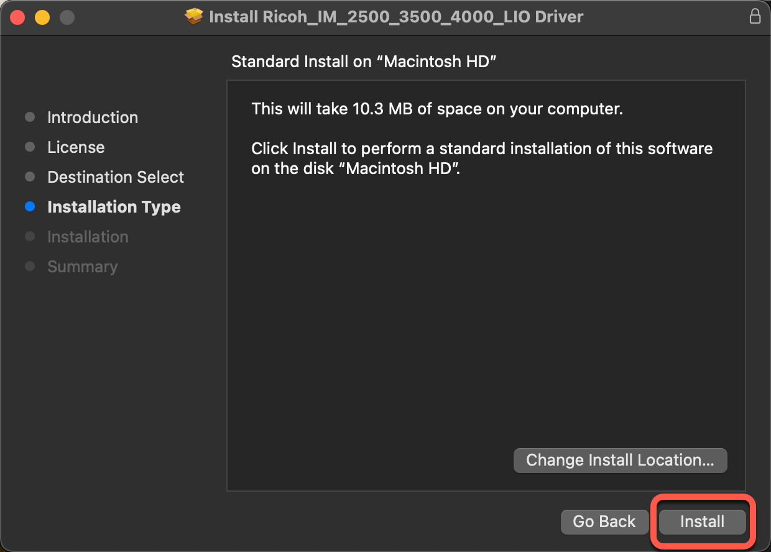

  - A new window will open for authentication
    - Input your admin or user account password
    - Click on Install Software

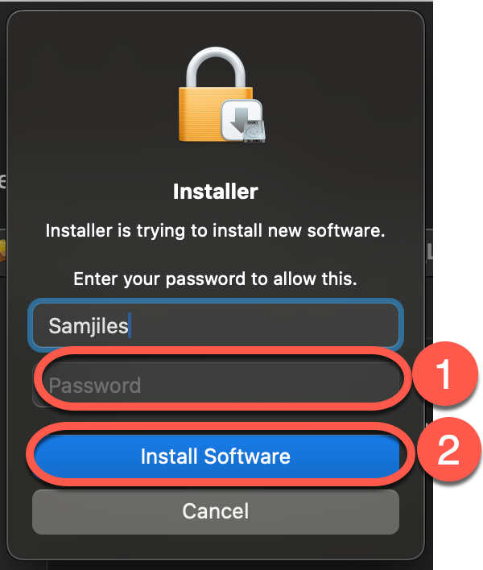

  - On the next window. Click Close

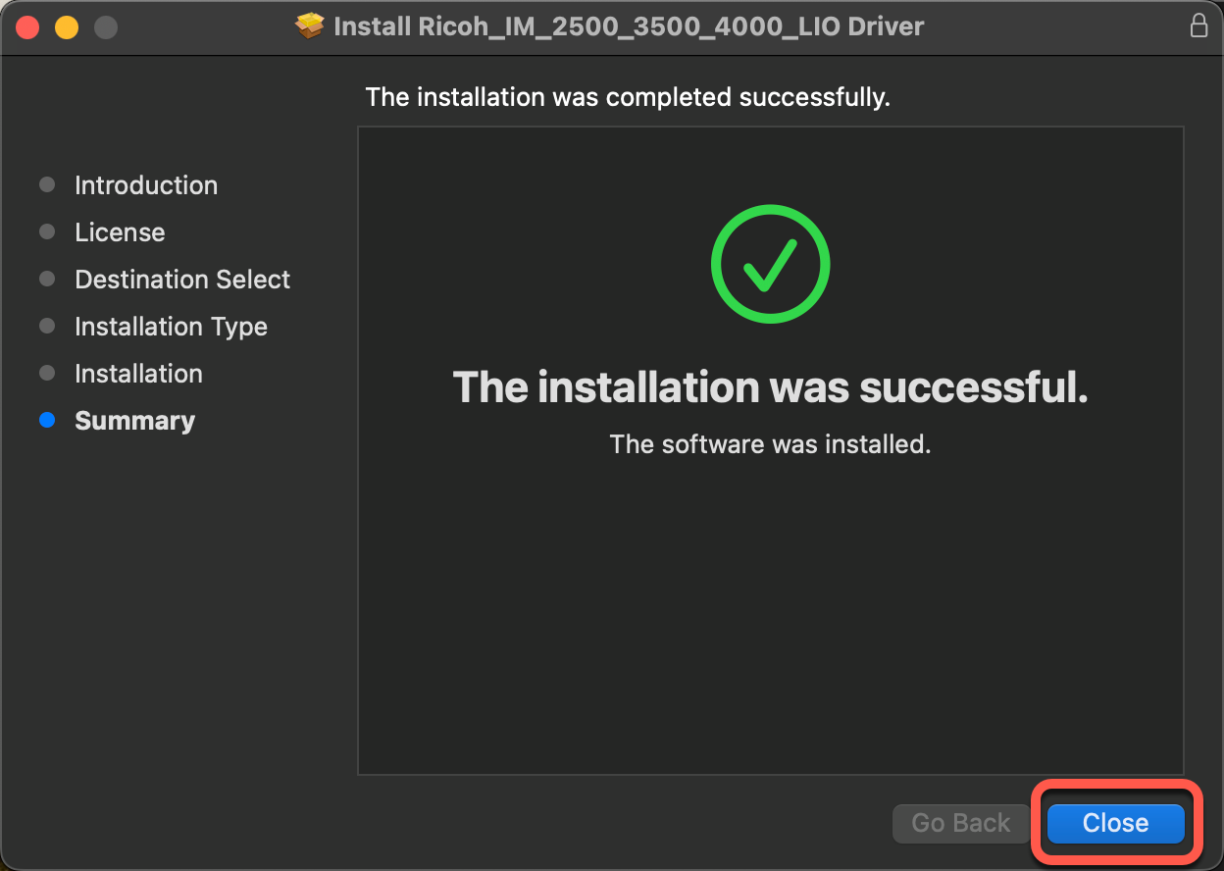

  - Either keep or delete the Ricoh printer driver

