DOWNLOADING RICOH PRINTER DRIVERS

Pre-requisit:

Identify the printer model e.g. Ricoh IM 550 / IM C400 / IM C3010 / IM 5000
  - The printer model is labelled on the physical printer (usually in front)

- Download Ricoh printer drivers from https://www.ricoh.ca/en-CA

- On the top row options:
  - Click on Support & Downloads
  - On the left side of the Windows. Click on Support

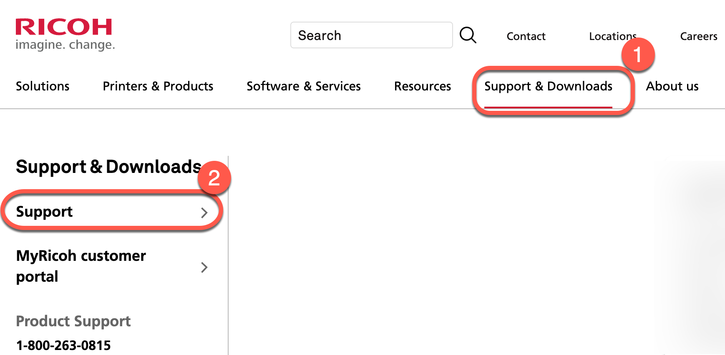

- After clicking on Support. Click Drivers & Software

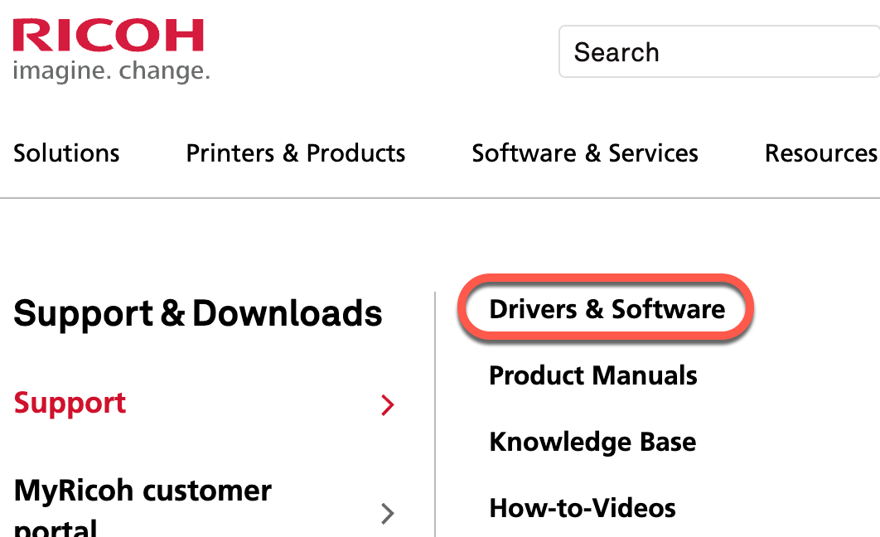

- In the search box on the left side of the window
  - Input(Type) the model number of the printer e.g. IM 5000 or IM C400F
  - Click the search magnifying glass or press the Enter/Return button on the keyboard

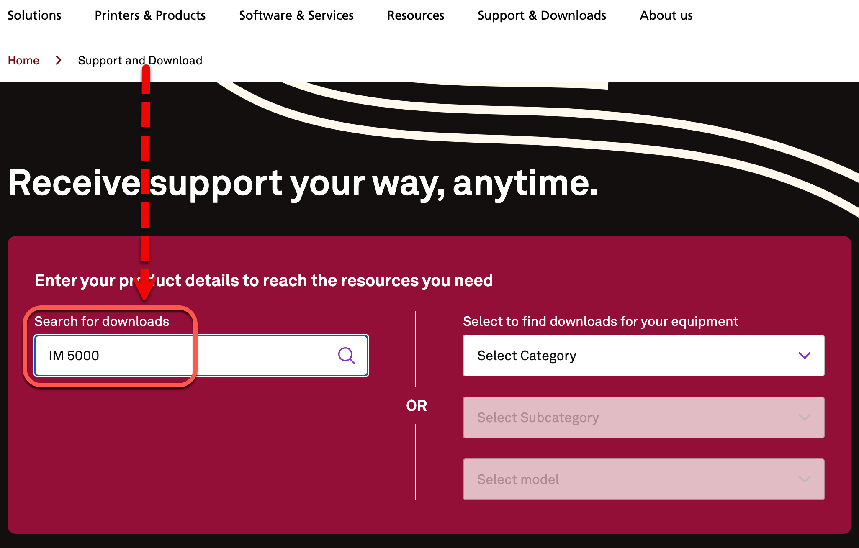
- On the next screen under the Drivers tab. Click on the printer model number e.g. IM 5000

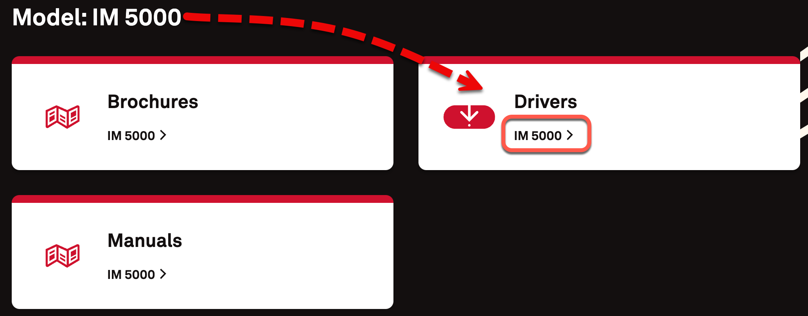

- On the next screen, accept the software license agreement. Click on I Agree

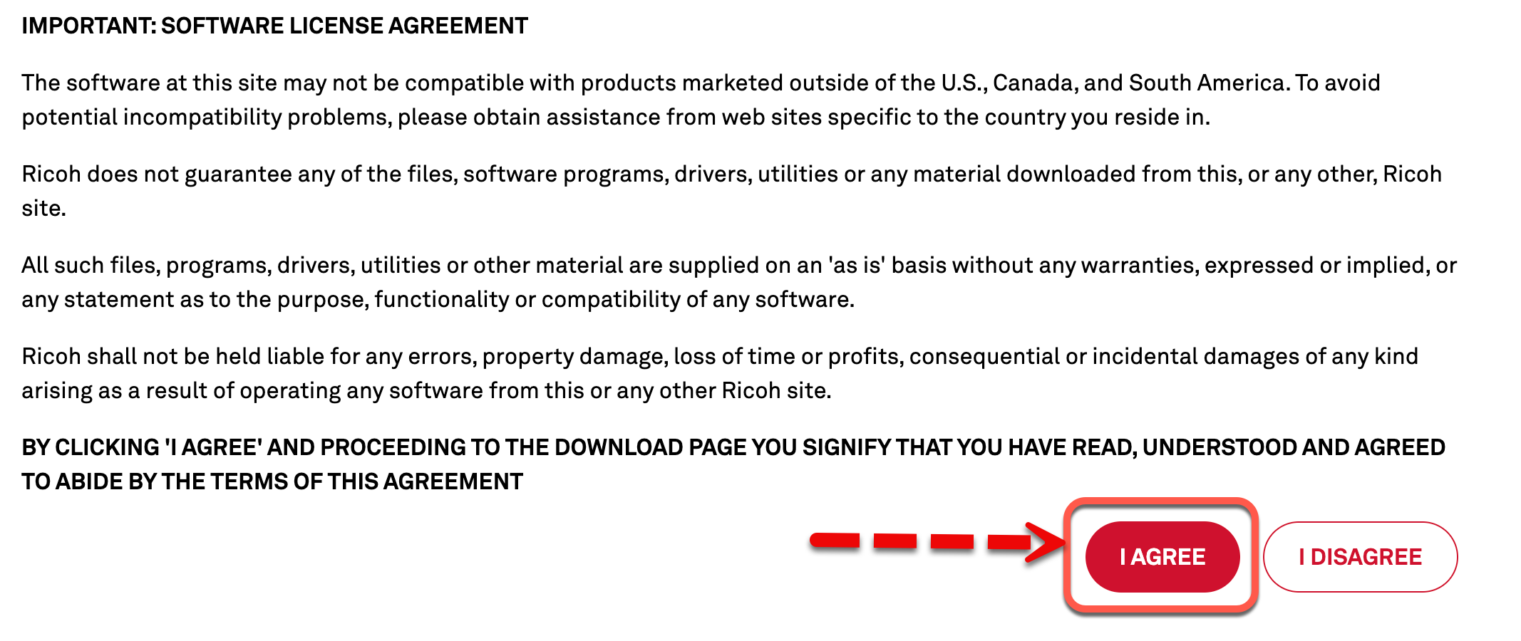

- Choose your computer Operating System (OS) either Windows or Mac OS X

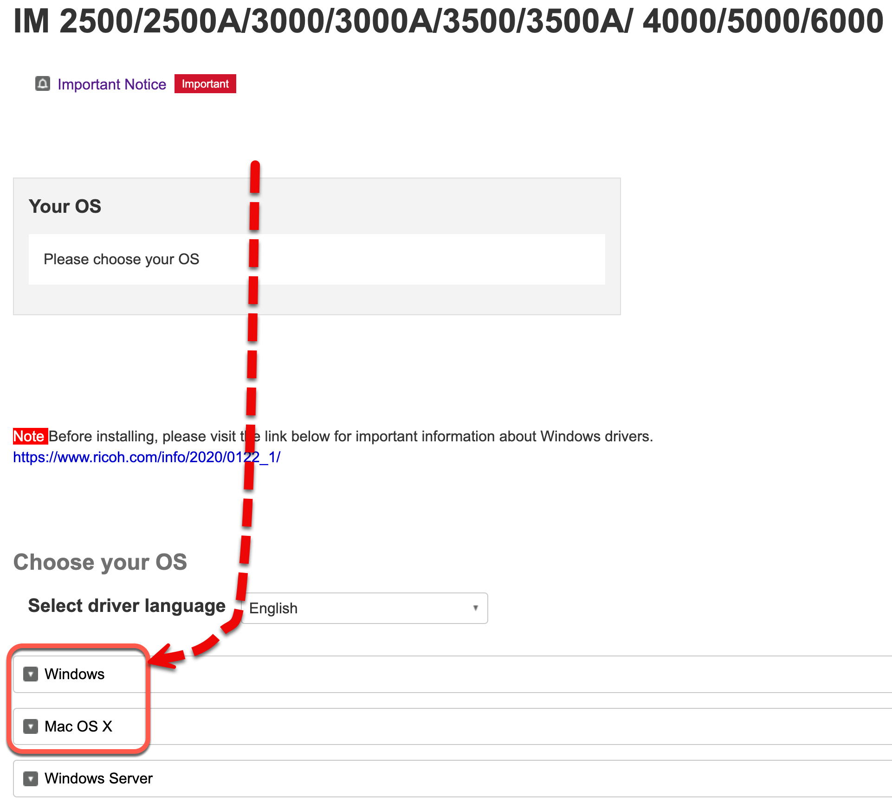

- Under title heading labelled Choose your OS Click on the arrow on the left side of the OS either Windows or Mac OS X
  - Select the appropriate OS version

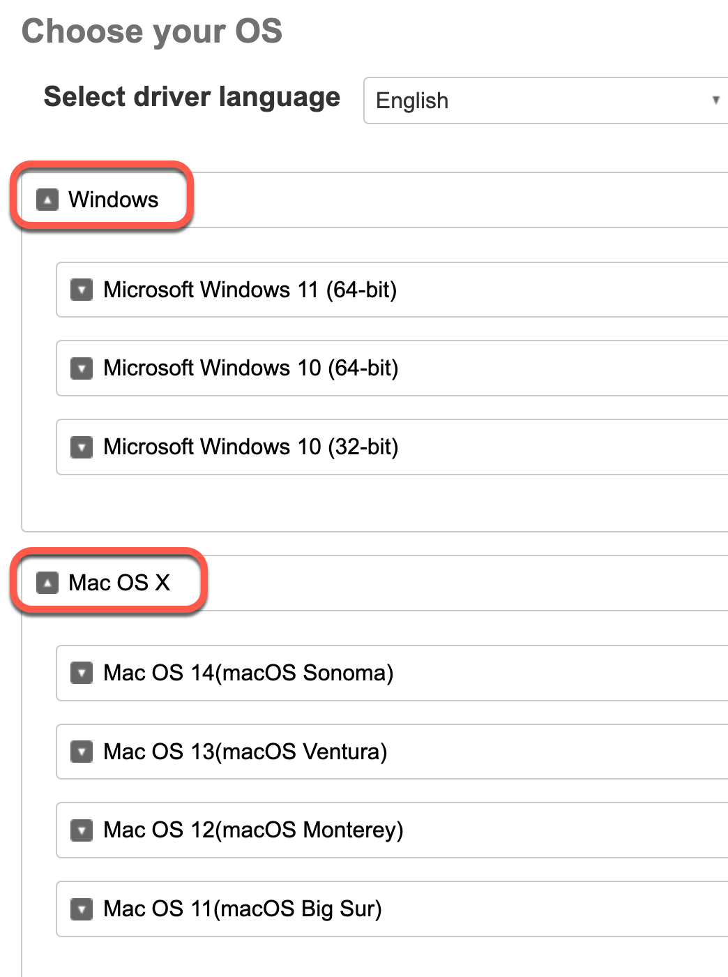
- After selecting the appropriate OS version
  - Click on the Dropdown Arrow on the left side of the OS version

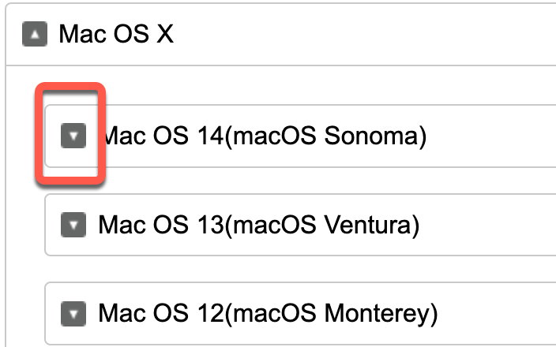

- The printer driver will be available. Click on Download

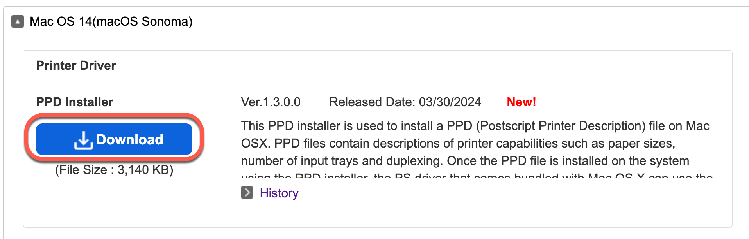

- Save the driver on your computer. Somewhere you can access the downloaded file.

