HOW TO ADD RICOH PRINTER ON MAC

- Open System preferences / System Settings depending on your Mac OS versiom
  - On the left of the window. Click on the Apple icon
  - Click on System Preferences / System Settings
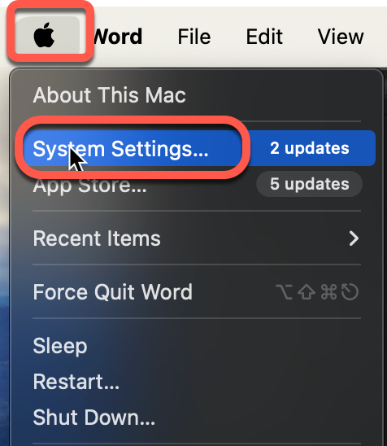

- A new window will open
  - Use the search field in Systems Settings to find Printer & Scanner

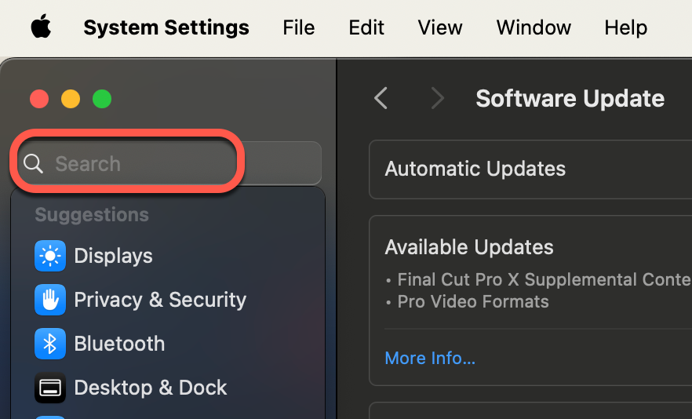
  - Click on Printer & Scanner

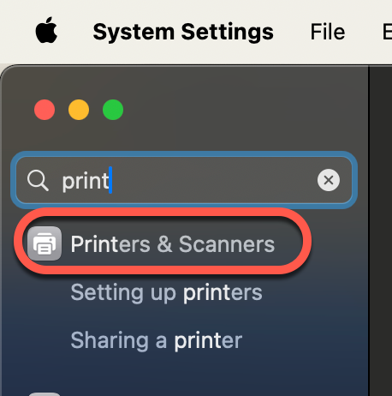

  - On the right side of the window. Click on Add Printer, Scanner, or Fax..

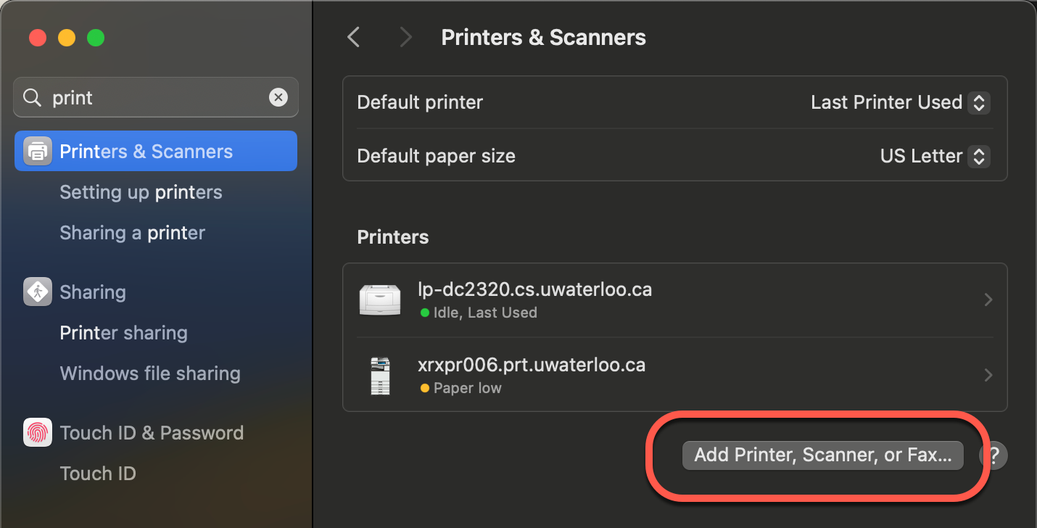

  - A new Add Printer window will open
    - Click on the Globe icon labelled - IP
    - In the Address field: Input the IP address e.g. 172.19.5.126
    - In the Use field: Click on the drop-down and choose Select Software

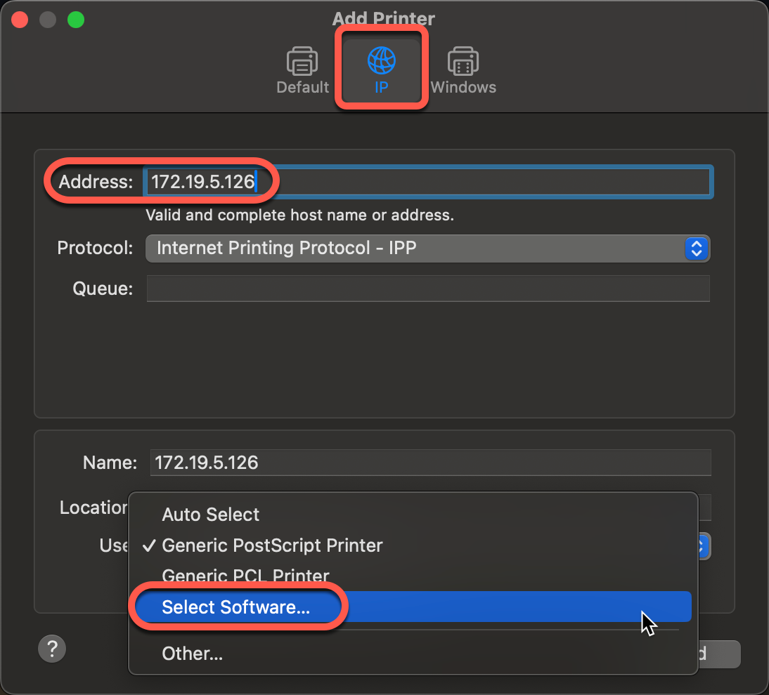

  - A new Printer Software window will open
    - Search for the printer software driver e.g. Ricoh
    - Choose the correct driver from the list e.g. RICOH IM 5000 PS
    - Click OK

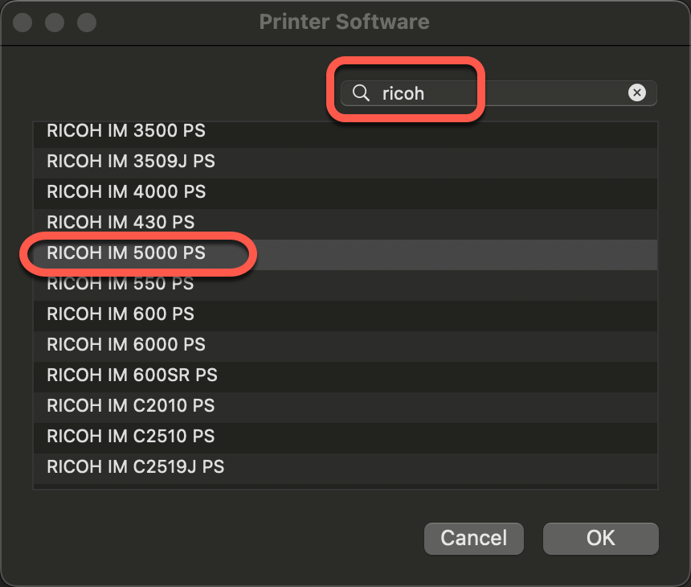

  - In the Add Printer window
    - Click on Add

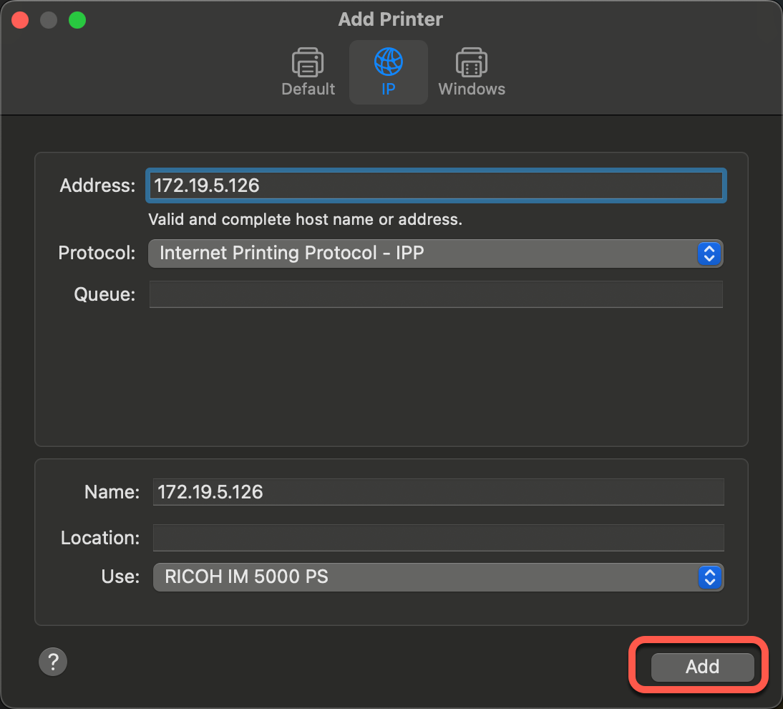

- Confirm the printer was successfully installed
  - Return to the Printer & Scanner window
  - The printer should be listed under Printers

