Creating UW Sponsored Net IDs

The purpose of a uWaterloo sponsored guest Net-ID is to provide wireless access to uWaterloo guests who may not already have an Eduroam account, or for bulk creation of short term userids that may be required for a conference or gathering.

Navigate to the following URL in your web browser: https://netid.uwaterloo.ca/

If you are not already logged-in to UW’s Central Authentication Service (CAS) you will be presented with the CAS login screen; log in with your WatIAM credentials:

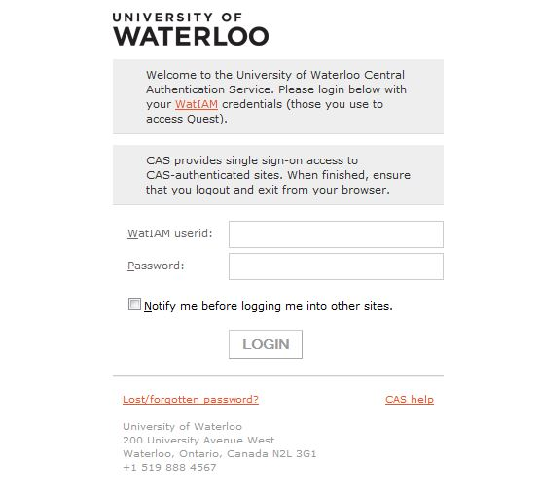

Once on the Net-ID web page, click on the Manage my Net-IDs button near the centre of the page:
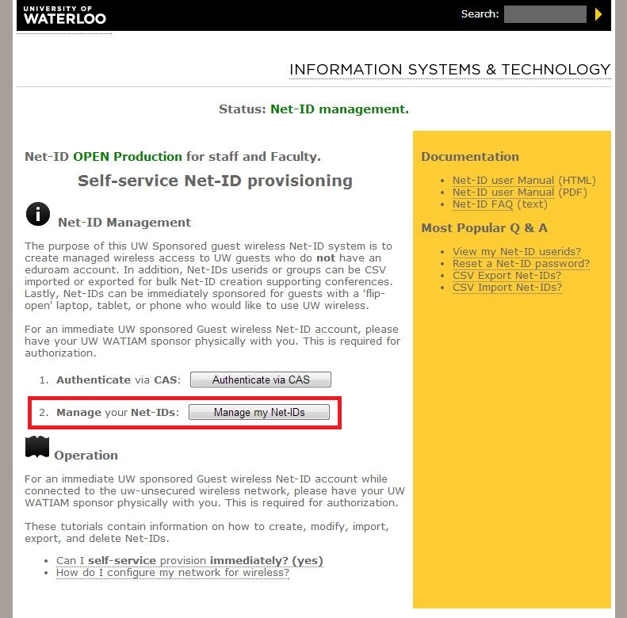

On this page, click the Group Add button:
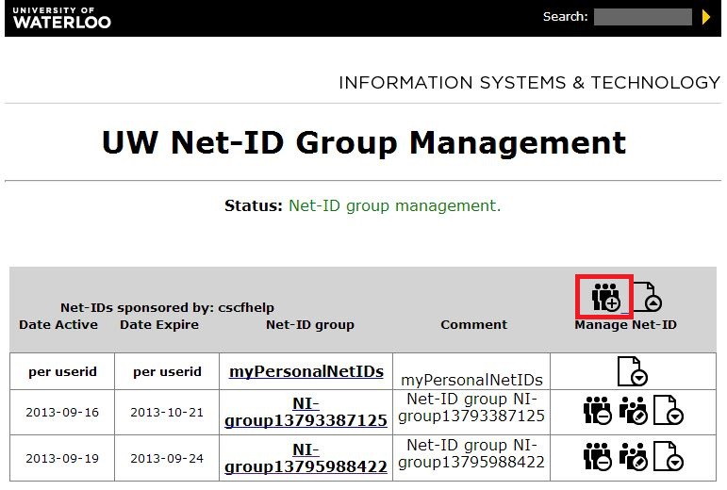

Complete all the fields. The group userid prefix will be prepended to each user ID created. For example, if you set it to “conference1”, all your net IDs will be of the form:
“conference1-xxx@netid.uwaterloo.ca” where xxx represents a unique number in that group.

When you have completed all fields, click the Create Net-ID group button:

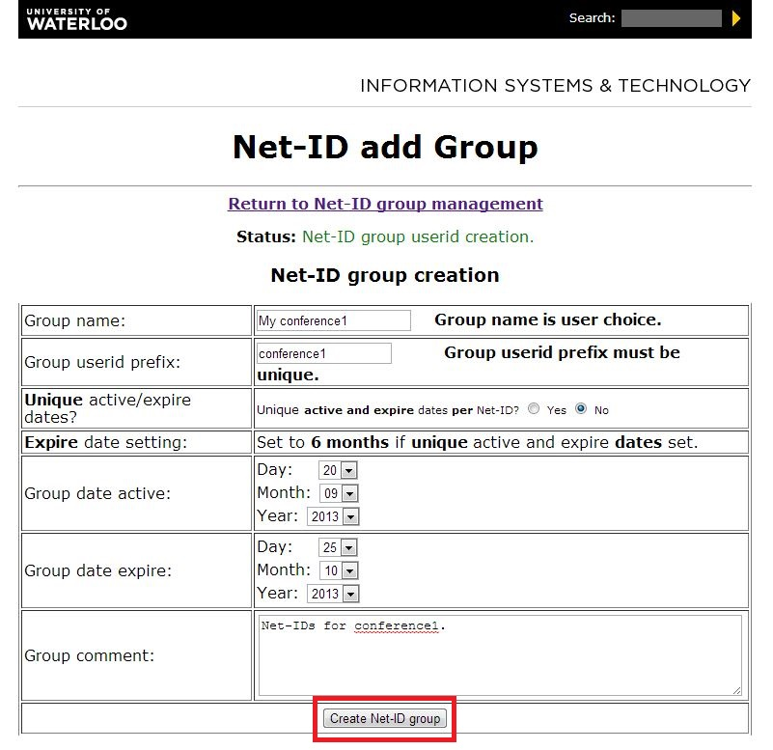

You will have to enter a unique group name (one that you are not already using) and a unique group userid prefix (one that no one is using right now). The system will present an error at the top of the page, like the one below, if the name you entered was not unique:
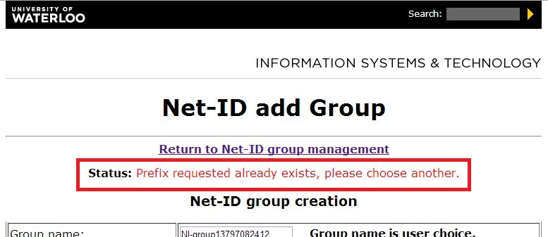

If successful, you will be directed back to the UW Net-ID Group Management page. From there, click on the name of the net ID group you just created:

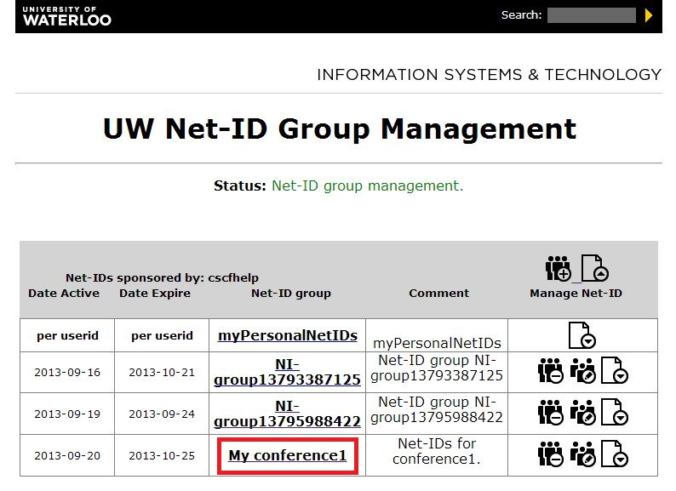

There are no user IDs in your group yet, you will need to add some. To do this, click on the Userid Add button:

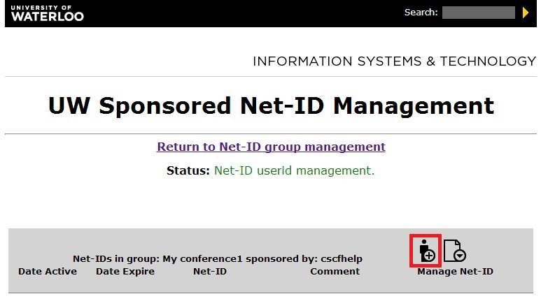

In the Net-IDs to create field, enter a number between 1 and 500. Under this field, click the radio button Yes to have an email sent to you containing the user IDs and passwords for the IDs you will create. Once complete, click the Create Net-ID button at the bottom of the form:
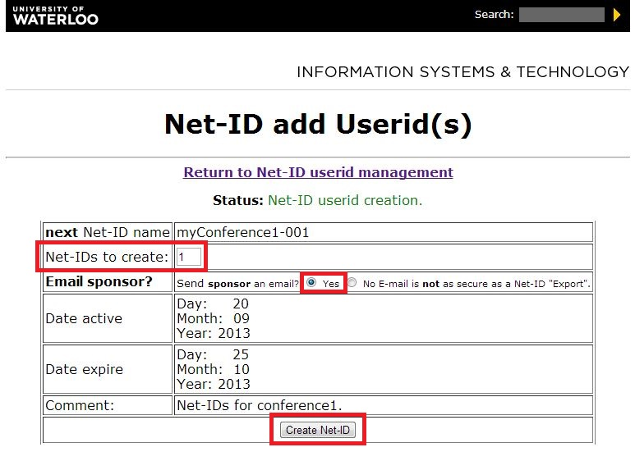

After clicking the Create Net-ID button, you will see a confirmation page similar to the one below:
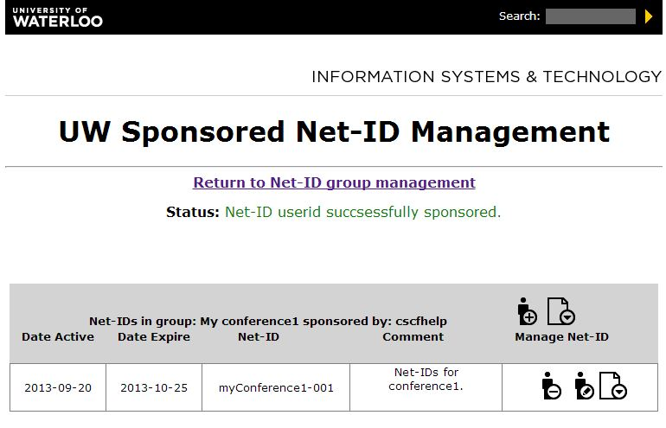

Shortly after creating your net IDs, you should receive an email with details about the IDs you just created. This email will also contain the IDs and associated passwords for each ID:
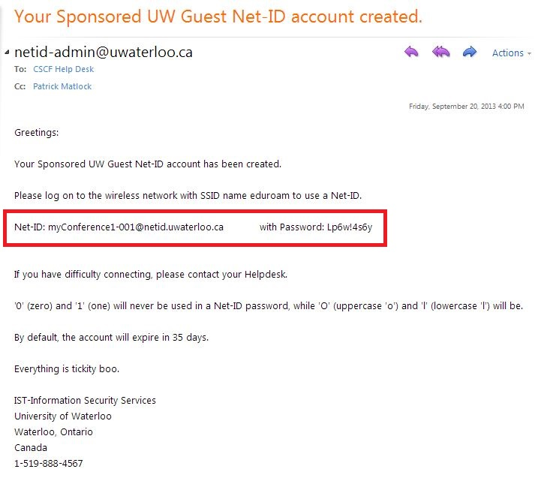

If you set the “date active” to the current day when creating the net ID group, then the net IDs can be used immediately to access the network.

For instructions on how to configure the wireless network, visit the following URL:
https://ist.uwaterloo.ca/cs/wireless.html

Questions?
Please contact the CSCF Help Desk at cscfhelp@uwaterloo.ca or extension 31100.

