The
Cheriton School of Computer Science:
SACA System V.2.7.6
User Guide
--------
CHAIR VIEW

Last revised: December 20th, 2020

Introduction 5
System Specifications 5
The Application Path 5
2.1 The Application Path Chart 5
2.2 Application Path Statuses (“Nodes”) Explained 6
2.2.1 Application Submitted 6
2.2.2 Withdrawn 6
2.2.3 Chair Review 7
2.2.5 SACA Review 7
2.2.6 SACA Reject 7
2.2.7 Hold Application 7
2.2.8 Short List 7
2.2.9 Interview 7
2.2.10 Rejected After Interview 7
2.2.11 Job Offered 7
2.2.12 Job Accepted 8
2.2.13 Job Declined 8
Common Chair Tasks 8
3.1 Reviewing Applicant Files 8
3.1.2 Overview 8
3.1.3 Reviewing Applicant Files 8
3.2 Creating/Updating Notes on Applicants 9
3.2.1 Overview 9
3.2.2 Creating or Updating a Note 9
3.2.3 Reading Notes on a File 12
3.2.4 Making School Review Comments as Chair………………………………………….12
3.3 Changing an Applicant's Status 12
3.3.1 Changing an Applicant's Status 12
3.3.2 Changing Multiple Applicant Statuses 14
3.3.3 Viewing an Applicant's Status 17
3.4 Applying Labels to Applicants 17
3.4.1 Overview 17
3.4.2 Applying a label to applicants 17
3.4.3 Viewing Labels 20
3.5 Archiving/ Un-archiving an Application 20
3.5.1 Overview 20
3.5.2 Archiving an Application 20
3.5.3 Un-archiving an Application 21
3.4.4 Viewing Archived Applicants 22
3.6 Rejecting and Freezing Applications 22
3.6.1 Overview 22
3.6.2 Rejecting an Application 23
3.6.3 How to Freeze an Application 24
3.7 Sorting Applicants within a Job 25
3.8 Downloading PDFs of Applicants 26
Chair Admin Tasks 27
4.1 Job Management 27
4.1.1 Required Fields Explained 27
4.1.1.2 Job Type 27
4.1.1.3 Description 27
4.1.1.4 Visibility 27
4.1.1.5 Custom Rejection Letter 27
4.1.1.6 Editable Rejection Letter 28
4.1.1.7 Show Labels to Regular Faculty 28
4.1.2 Adding a New Job 28
4.1.3 Editing an Existing Job 29
4.1.4 Deleting an Existing Position 30
4.2.1 Overview 31
4.2.2 Viewing Summary Statistics 31
User Management 37
5.1 Navigating the User List 37
5.1.1 Overview 37
5.1.2 User Categories 37
5.2 Editing Users 38
5.2.1 Updating a User’s Privilege (to Chair/SACA/School/Disabled) 38
5.2.2 Updating First and Last Name Fields 38
5.2.3 Updating the WatIAM Userid 39
5.2.4 Disabling a User 40
5.3 Adding Users 41
5.3.1 Overview of Field Names 41
5.3.2 Adding Users: Chair/ SACA/ School/ Disabled Member 41
Miscellaneous Questions on… 42
6.1 Accessing the Website: How do I… 42
6.1.1 Validate my username and password? 42
6.1.2 Log in? 43
6.1.3 Log Out? 43
6.1.4 Change my view to be SACA/Admin/School? 43
6.2 Job Management: How do I… 43
6.2.1 Hide Jobs from Applicants? 43
6.2.2 Restore a Deleted Job? 43
6.2.3 Add/Edit/Delete a Job? 43
6.3 User Management: How do I… 44
6.3.1 Check that the user was added/edited/deleted? 44
6.3.2 Add/Edit/Delete Users? 44
6.3.3 Categorize Users? 44
6.3.4 Recover a Disabled (Deleted) User? 44
6.4 Reference Letters: How do I… 44
6.4.1 Sort applicants? 44
6.4.2 Know when I’ve reached the limit? 44
6.4.3 Check if References have been uploaded? 44
6.4.4 Delete a Reference Letter? 44
6.5 Archived Files: How do I… 44
6.5.1 Sort applicants? 44
6.5.2 Access an applicant’s contact information? 45
6.5.3 Delete an Application? 45
6.5.4 Interpret the column headings? 45
6.6 Report Statistics: How do I… 45
6.6.1 Sort Reports? 45
6.6.2 Know if an applicant has any uploaded files? 45
6.6.3 Interpret the column headings? 46

Introduction
The Faculty Recruiting system’s Chair View is designed for privileged users to manage jobs, view candidate files, view applied and archived files, post comments, read comments submitted by other users, and organize faculty-recruiting information within the Cheriton School of Computer Science. This guide is divided into five sections: System Specifications, Application Path, Common Chair Tasks, Common Admin Tasks and Miscellaneous Questions.

System Specifications
Any modern system utilizing a modern browser should run the Chair system with no issues. The following browsers have been tested and confirmed to work.
- Google Chrome
- Firefox

- Opera
- Safari

Firefox and Google Chrome are recommended and fully supported.

The Application Path
Upon submission by the applicant, the path of each application is determined by the decisions of the Chair, SACA members, and applicant.

2.1 The Application Path Chart
In the diagram below, the red arrows represent the path influenced by the Chair. The blue and green arrows represent decisions made by SACA members and the applicant, respectively. The Chair is responsible for changing the application’s status in each step. Each step of the application process is represented by a node. Nodes representing end statuses are bolded. When an application reaches an end status, a final decision has been made. It is up to the Chair to communicate with the applicant about the final decision. There is a mechanism to send rejected applicants a rejection email within the system. See the section below on “Nodes Explained” for a detailed explanation of each status, and sections 3.3 Changing an Applicant’s Status, 3.5 Archiving/Unarchiving an Application, and 3.6 Rejecting and Freezing Applications.

While in any status, the applicant may update their files, and additional reference letters may be requested and submitted.

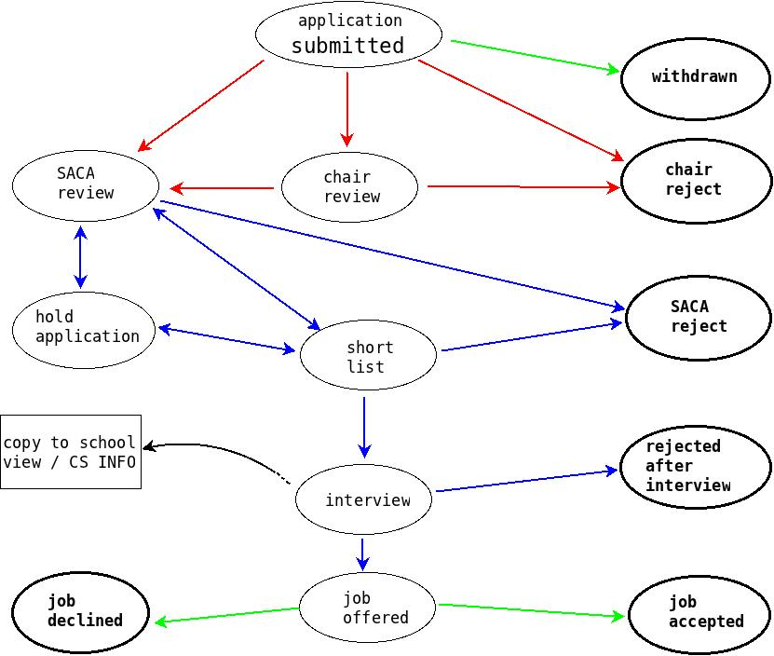

2.2 Application Path Statuses (“Nodes”) Explained

2.2.1 Application Submitted
The default or starting status for all applications. The applicant has submitted a CV and cover letter, but the files have not been reviewed by the Chair. The Chair may choose to progress the application to “Chair Review” – or they might choose to move it straight from “Submitted” to “Chair Reject” or “SACA Review”. When in the “Application Submitted” status, on the applicant’s page to apply for jobs, this job is marked as “APPLIED”. When the status is changed from “Application Submitted” to any other status, on the applicant’s page the job is marked as “UNDER REVIEW”. This includes when the status becomes any of the terminal statuses- the web interface does not notify the applicant of these changes.

Note: If the applicant's files do not include the required number of reference letters, the applicant should not be reviewed.

2.2.2 Withdrawn
The applicant has withdrawn the application. This is an end status (bolded in this diagram); the file should be archived and then frozen. Archiving an application removes the candidate from the list of applicants. Freezing the application prevents its status from being changed or accidentally rejected.

2.2.3 Chair Review
The applicant's files are currently being reviewed by the Chair. Then the Chair decides if the application should be reviewed by SACA members. If so, the Chair marks the file “SACA Review”. Otherwise, the Chair may reject the applicant.

2.2.4 Chair Reject
The Chair does not want to further proceed with the applicant. This is an end status; the application should be archived, then rejected. A pre-formatted rejection letter will be emailed to notify the applicant of the decision.

2.2.5 SACA Review
The applicant's files are currently being reviewed by the SACA committee. If there is support from the committee members to interview the applicant, the application may be forwarded to the Short List. If the committee cannot reach a decision, the application's status may be changed to Hold.

2.2.6 SACA Reject
Upon review by the SACA committee, a decision has been made not to proceed with the applicant. This is an end status; the application should be archived, then rejected. A pre-formatted rejection letter will be emailed to notify the applicant of the decision.

2.2.7 Hold Application
The SACA committee has not reached a decision. The application is being held for further review.

2.2.8 Short List
The SACA committee supports to interview the applicant. The application is subject to further review in the near future. Additionally, the Chair may optionally allow Regular Faculty to see “Short List” applications matching a particular label: see under Job Management section: 4.1.1.7 Show Labels to Regular Faculty

2.2.9 Interview
The Chair and SACA committee members support interviewing the applicant. The candidate is currently in the interview process. Files pertaining to candidates with “Interview” status will be made automatically visible to all regular faculty members (copy sent to CS-info).

2.2.10 Rejected After Interview
The candidate has been reviewed by the Chair, SACA committee and faculty members but has not been found agreeable during the interview process. This is an end status; the application should be archived, and then rejected. The Chair should send the applicant a personal rejection letter.

2.2.11 Job Offered
After the interview, the Chair, SACA committee and faculty members, support hiring the applicant. A job offer has been made, and a decision from the candidate is being awaited.

2.2.12 Job Accepted
The candidate has accepted the job offer. This is an end status; the application should be archived and then frozen. Freezing the application prevents its status from being changed or accidentally rejected. Note that after the recruiting cycle is finished, data from previous cycles is batch-deleted for privacy reasons.

2.2.13 Job Declined
The candidate has declined the job offer. This is an end status; the application should be archived and then frozen. Freezing the application prevents its status from being changed or accidentally rejected.

Note: For more information on Waterloo policies on records retention, follow (Ctrl + click) one of the links below.
Records Management: http://uwaterloo.ca/records-management/records-classification-and-retention-schedules/human-resources
Records Storage and Disposal: http://uwaterloo.ca/records-management/records-storage-and-disposal

After the recruiting cycle is finished, data from previous cycles is batch-deleted for privacy reasons. See section 4.1.4, Deleting an Existing Position.

Common Chair Tasks
The following are instructions for most tasks frequently done by the Chair.

3.1 Reviewing Applicant Files

3.1.2 Overview
Applicant files are all documents pertaining to a certain job candidate, uploaded by the candidate or the references. For an application to be considered, the applicant must upload the following files: CV, Teaching Statement, and Research Statement. Other files, such as Cover Letter and Recent Publications, are not required. An applicant must also submit at least three references.

Note: For jobs describing a “Lecturer” position, Research Statement may describe their plans for scholarly activity more generally.

Application files may be viewed by the Chair, SACA committee, and faculty members to aid with the faculty recruitment process.

3.1.3 Reviewing Applicant Files
These instructions concentrate on tasks specific to the Chair. For information on reviewing applicant files, see Section 4.1: “Applicant Files” in the SACA View Manual. To access SACA view, which has a link to the SACA Manual, go to the Home page of the application and choose “SACA” from the drop-down in the middle of the page. (This is different from the “SACA Review Candidates” in the left-hand menu.)

If an applicant has previously applied for a job, they may ask the Chair whether they can re-use their previous year’s log-in. The answer is yes, they can. The Chair should tell them they are welcome to update any of their uploaded files, and they may want to delete last year’s references and then re-ask their references for updated letters.

The Chair has the ability to sort applications in the following ways: Alphabetical by Last Name, Application Date, Alphabetical by PhD Institution, Rank Sought, Application Status, Date Last Modified by Chair, Average Rating, and Review Count.

Additionally, there is a column which reports the most recent file-update time for each applicant.

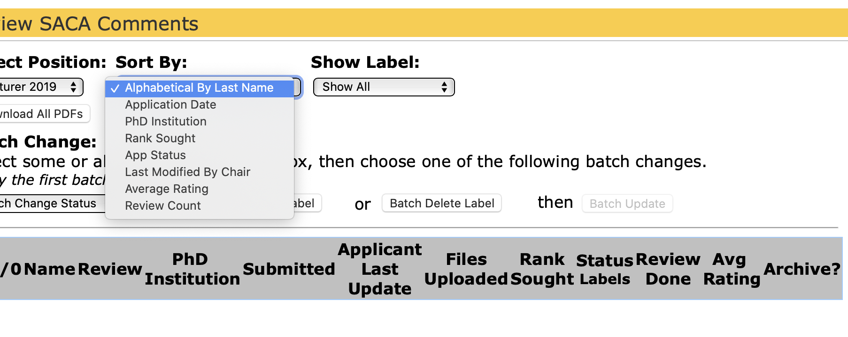
The Chair and SACA members have access to a Summary Page for each applicant, by clicking on their name in the SACA View page.

From this summary, they will see an expanded view of the applicant and their uploaded files.
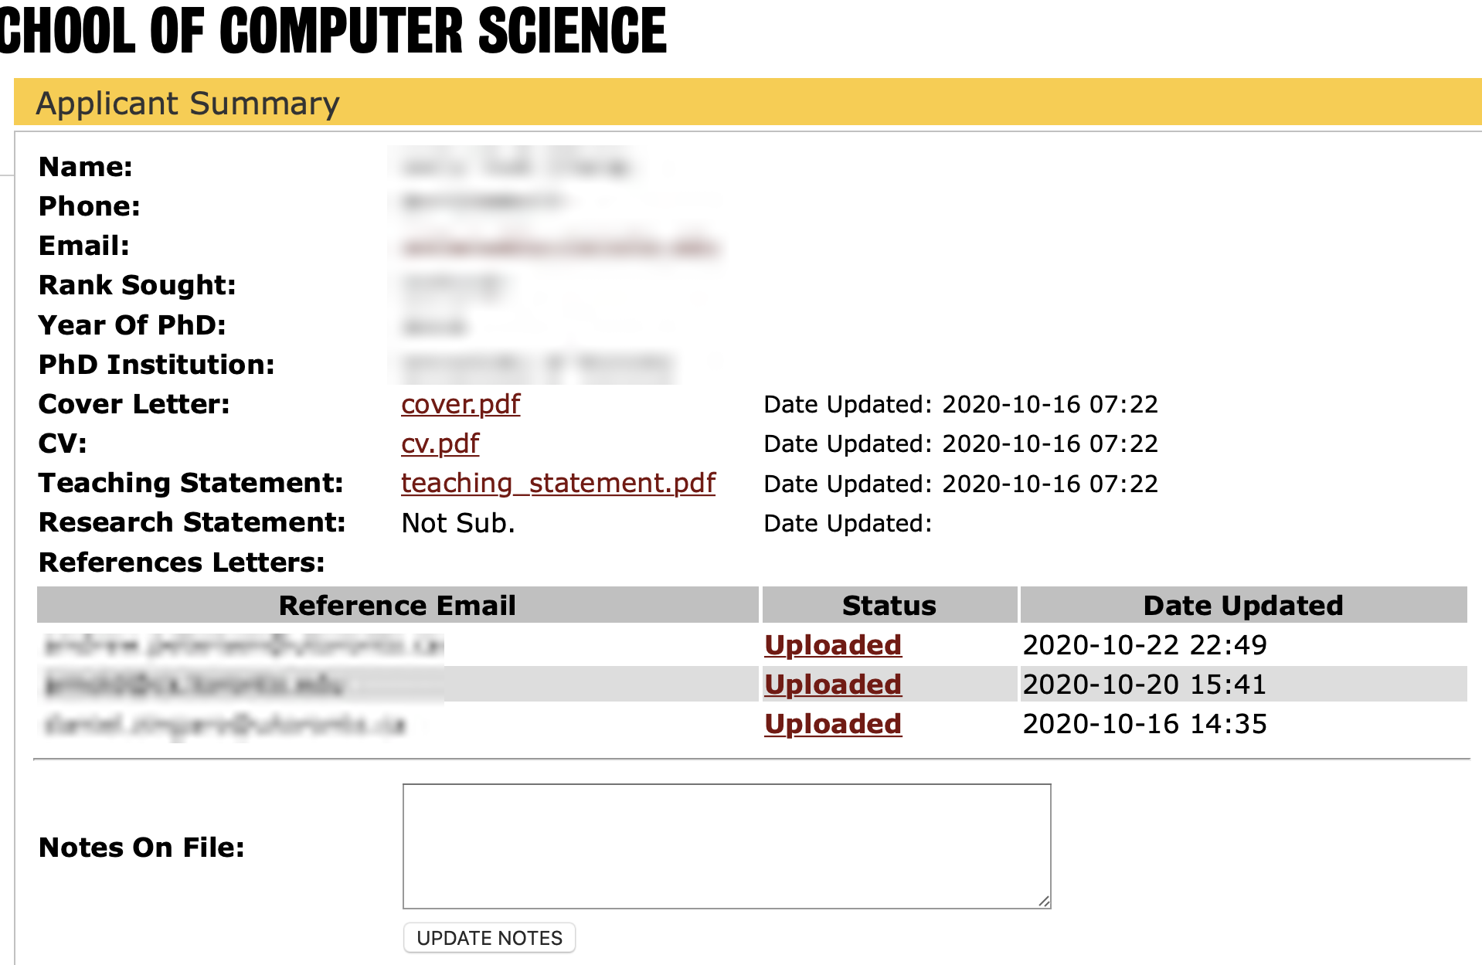

This expanded view includes all of the applicant’s uploaded files, including a time stamp of when each file was last updated.

It also includes “Chair Notes” described in the next section.

3.2 Creating/Updating Notes on Applicants

3.2.1 Overview
Exclusively, the Chair has the ability to create, update and read notes on all applicants. Notes are optional. Notes written by the Chair are visible only to users with a Chair status.

Note that the Chair may also make “SACA Review” comments (visible to SACA members) and “School Review” comments which are visible to all members of the school and may include URL links.

Please see the SACA View Manual sections 3.1 and 4.2 for details on SACA Review comments. To access SACA view, which has a link to the SACA Manual, go to the Home page of the application and choose “SACA” from the drop-down in the middle of the page.

Please see section 3.2.4 below for details on School Review comments.

3.2.2 Creating or Updating a Note

In the text box corresponding to “Notes on File:” create a new note, or update an existing note.

If no notes exist on the applicant, enter the first note in the comment box and select “UPDATE NOTES”.

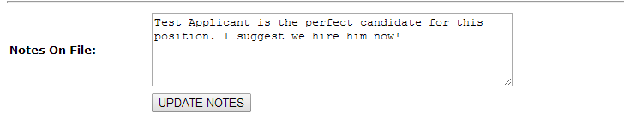

If a note on the applicant already exists and you wish to create an additional but separate note, create a page break by entering a few dashes (“---”) on a new line directly beneath the previous note. Enter a note, and select “UPDATE NOTES” to save the updates.

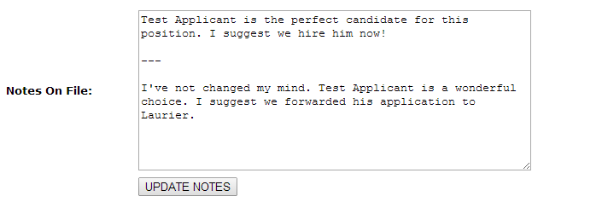

To edit or update a previous note, enter your updates directly into the comment box without creating a page break. Select “UPDATE NOTES”; the updated note will overwrite the previous note.

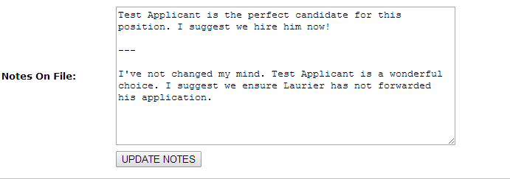

Provided no errors, the page will momentarily redirect to display the message below:

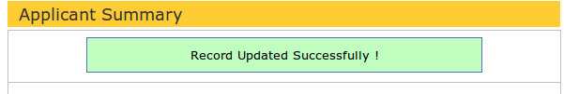

The page will redirect back to “Applicant Summary”; the new note should appear in the text box. When finished creating or updating the Notes, exit the tab; all notes will be saved in “Notes on File” under the “Applicant Summary” tab and can be viewed exclusively by those with Chair access.

Likewise, notes may be updated by selecting the “SACA Review” tab, then “Submit Review” under the “Review” column.
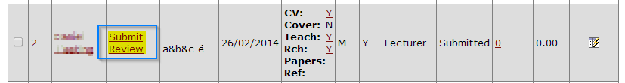

The page will redirect to “Add Comments/Change Applicant Status”. Under “Chair Tools” and in the text box labelled “Notes on File:” create a new note, or update an existing note:

If no notes exist on the applicant, enter the first note in the comment box and select “UPDATE NOTES”.

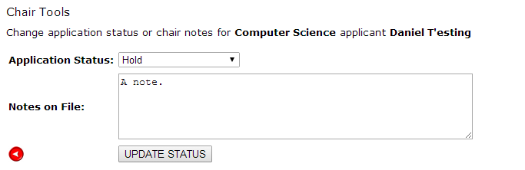

If a note already exists and you wish to create an additional but separate note, create a page break by entering a few dashes (“---”) on a new line directly beneath the previous note. Enter a note, and select “UPDATE NOTES” to save the updates.

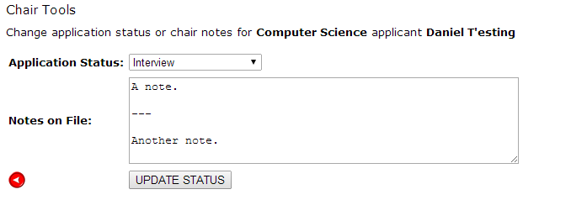

To edit or update a previous note, enter your updates directly into the comment box without creating a page break. Select “UPDATE NOTES”; the updated note will overwrite the previous note.

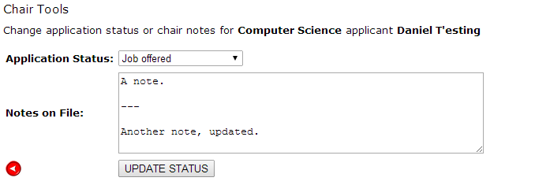

Provided no errors occurred, the page will momentarily redirect to “Review SACA Comments”. A message reading “Record Updated Successfully!” will appear directly below the page heading.
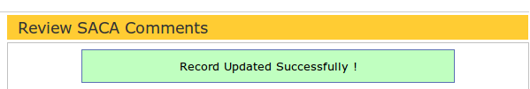

3.2.3 Reading Notes on a File

From the navigation menu on the left-hand side, select “SACA Review”. Select the name of the applicant of interest. The page will direct to “Applicant Summary”. Any notes on the applicant will be displayed in the text box labelled “Notes on File.” Alternatively, select “Submit Review” and any notes on file will be displayed in the section “Chair Tools” in the text box labelled “Notes on File.”

3.2.4 Making School Review Comments as Chair
The “School Review” section of the application allows all members of the School to comment on an applicant. These comments are different from SACA Review comments (only visible to SACA members and chairs) and also different from Chair Notes (only visible to chairs).

The “School Review” section is closely analogous to the “SACA Review” section. Following the “School Review Candidates” link in the left-hand menu will display the list of interview candidates. While this Chair manual doesn’t detail all features of the School Review Candidates section, it will note the following special Chair feature.
The Chair may make comments visible to all members of the School by selecting “Submit Review” and adding a comment. These comments on an applicant, made by a chair, will be promoted to the top of that applicant’s comments in a section called “Chair Comments”, and any URLs will become hyperlinks.
This will facilitate leaving instructions for School members to follow links outside of the recruiting system, such as for videos of lectures or other materials that don’t fit into the standard application files.
The “School Review Candidates” section has a column called “Files” which is analogous to the identically named column in the “SACA Review” section, with an extra flag called “Links.” If the chair has left a comment, it shows “Links: Y” with a hyperlink to the School Review Comment by the chair.

3.3 Changing an Applicant's Status
Anytime a candidate advances a node in the Application Path, it is necessary to update the applicant's current status. An applicant's current status is visible to users with access to the Faculty Recruiting Application.

3.3.1 Changing an Applicant's Status
From the menu located on the left-hand side, select the “SACA Review” tab.
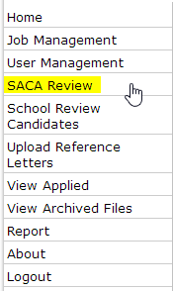

Locate the name of the applicant. Under the column entitled “Review”, click “Submit Review”.

Submit Review will link to a page entitled “Add Comments/ Change Applicant Status”. In the Chair Tools section, select the appropriate status from the drop down menu corresponding to the Application Status.
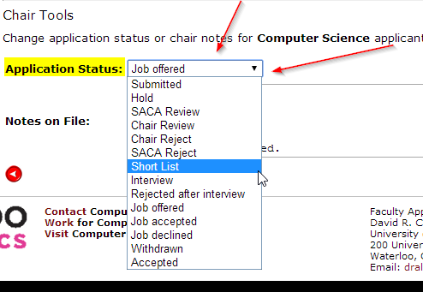

For aid in selecting an appropriate status, see Section 2: Application Path, Application Path Statuses Explained (2.2)

3.3.2 Changing Multiple Applicant Statuses
You can update multiple applicants’ application statuses at once. This is particularly useful for setting many applications to any of the “Rejected” statuses. If you batch-reject applications, they will automatically be archived as well. They will not automatically receive rejection letters. Sending the rejection letter must be done intentionally. See Section 3.6, Rejecting and Freezing Applications.

To perform the batch update you will need to navigate to the “SACA Review” tab.

Following is an example of how the batch editing works.

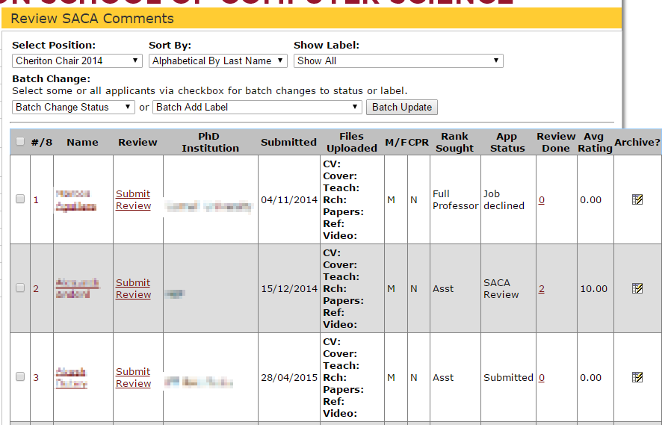

We have three applicants applying for the “Computer Science” job.

As a first example, you can select the top two users and change their “App Status” to “SACA Review”. To do so, simply select the checkbox on the left corresponding to each applicant’s row, and then under the “App Status – Batch Change” select the “SACA Review” option. Lastly, hit “Submit”. See below for a visual representation of these steps.
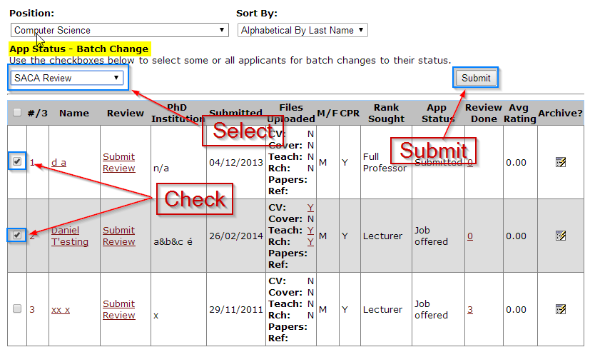

Once you hit the “Submit” button there should be a message saying “Record Updated Successfully” if the submission was successful.

As a second example, you can select all of the applicants in a job for a batch operation. If you look in the header row there is a check box in the leftmost column. This checkbox will automatically check off all the applicants in the row.

Simply click on the checkbox and all of them will be checked for the row.

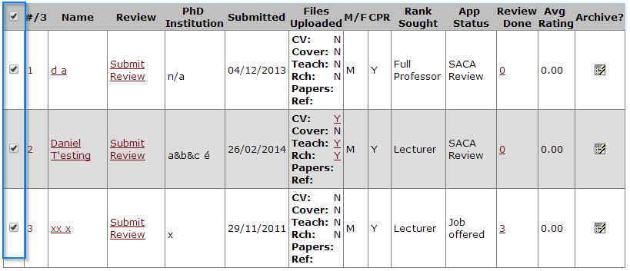

Proceed as described before to select the new status and hit “Submit”.

3.3.3 Viewing an Applicant's Status
From the menu located on the left-hand side, select “SACA Review”. Locate the name of the applicant of interest. The applicant's status will appear in the column entitled “Status/Labels”.

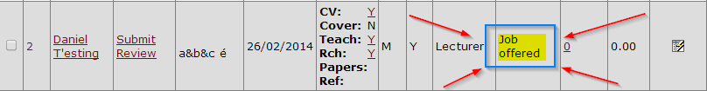

For a detailed description of each status, see Section 2.2: Application Path Statuses Explained.

3.4 Applying Labels to Applicants

3.4.1 Overview
You can optionally apply labels to applicants. These labels can be selected in the “SACA Review” and “School Review Candidates” lists to show only specific applications matching that label. Chairs, SACA members, and school members can all sort by label and view the labels attached to an application, however only the chair has the ability to apply these labels to applicants.

Additionally, the Chair may optionally allow Regular Faculty to see “Short List” applications matching a particular label: see under Job Management section: 4.1.1.7 Show Labels to Regular Faculty

3.4.2 Applying a label to applicants
Navigate to the “SACA Review” section

Within the SACA Review you are able to “batch add” labels to applicants. To do this you may select which applicants you’d like to apply a label to by using the check boxes on the left-hand side of the candidate
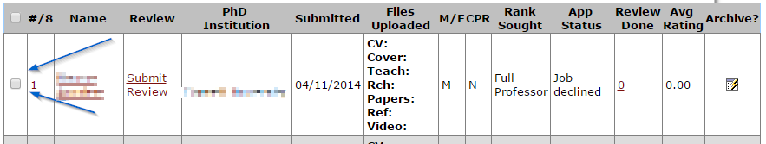
You may check multiple applicants at once and may also use the check box within the header column to check/uncheck all of the applicants at once.
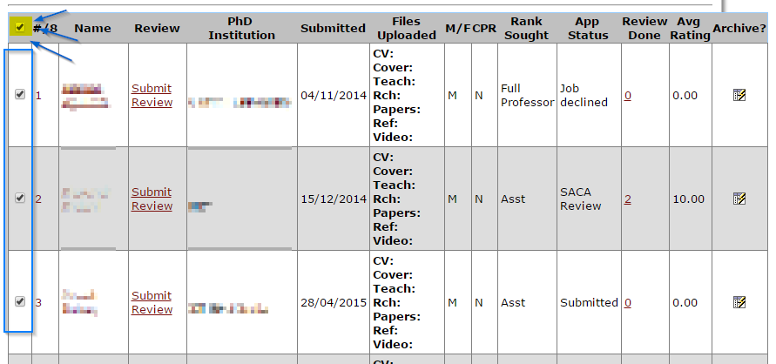
Once you have selected all of the applicants you’d like to apply a specific label to, open the “Batch Add Label” dropdown and pick which label(s) you’d like to add to the selected applicants.
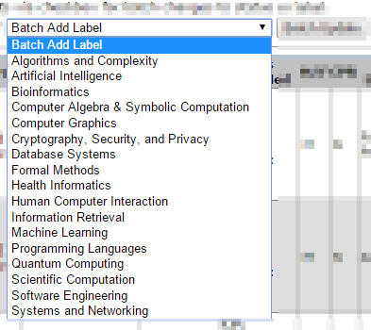
Once you have selected which label(s) you want to add to the applicants hit the “Batch Update” button.
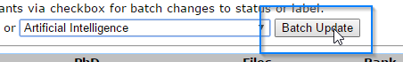

Once you hit this you should be presented with a success message.
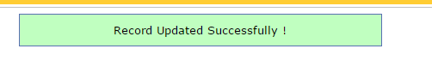
To summarize the actions you need to perform to apply a label:
- Check off the members you’d like to apply a label to
- Select the label(s) to apply
- Hit “Batch Update” button to apply the labels

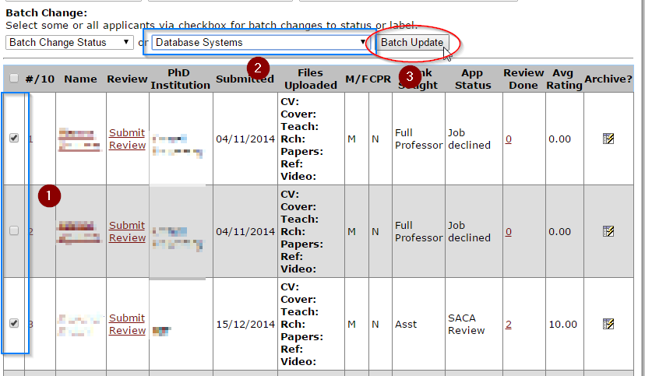

3.4.3 Viewing Labels
Chairs, SACA members, and School members will see labels in the “Status/Labels” column. Directly under the Status text, there will be smaller text with the list of labels applied to that application. If the dropdown option is chosen to only show applicants with a particular label, the “Status/Labels” column will also change to only show that label.

3.5 Archiving/ Un-archiving an Application

3.5.1 Overview
Users with Chair status have the ability to archive or un-archive applicants. Archiving an application removes it from the list of current applications. It is required that all applications that have reached an end status are archived. An end status signifies that a final decision regarding the applicant has been made; ergo the application is not subject to further review. Likewise, any application whose status is likely not subject to change should be archived. For more information, and examples of end statuses, see Section 2: Application Path.

If a job is archived, all applications under that job will also be archived automatically.

3.5.2 Archiving an Application
From the menu located on the left-hand side, select “SACA Review”. Locate the name of the candidate of interest. Under the column entitled “Archive?” click on the icon in the cell.

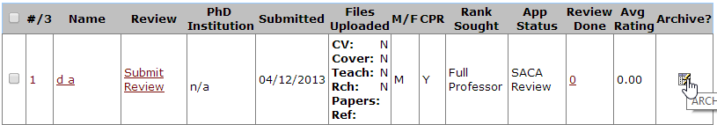

Provided no errors occurred, a message reading “Candidate Application Archived Successfully!” will appear directly underneath the page heading.
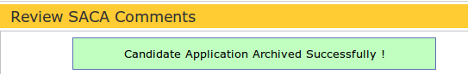

The newly archived applicant will no longer be listed in the table of applicants.

3.5.3 Un-archiving an Application
From the left-hand side menu, select the “View Archived Files” tab.

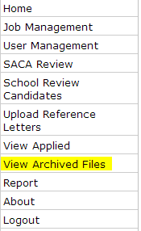

Locate the name of the applicant you wish to un-archive. Under the column entitled “UnArchive?” click on the icon in the cell.

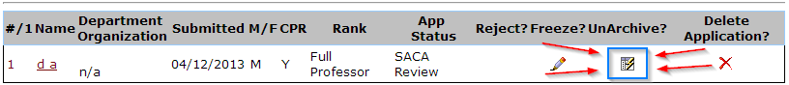

If the update was successful, a message reading “Candidate Application Un-archived Successfully!” will appear directly beneath the page heading.
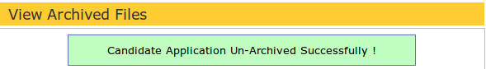

The newly un-archived applicant will no longer be listed in the table of archived applicants.

3.4.4 Viewing Archived Applicants
From the left-hand side menu, select the “View Archived Files” tab. The page will redirect to display a table listing all previously archived applications.

3.6 Rejecting and Freezing Applications

3.6.1 Overview

When an application has reached any of the following end statuses: Chair Reject, SACA Reject, and Rejected after Interview, the application should be archived then rejected.

If the application has not reached any of these statuses but is no longer in consideration, it is appropriate to instead freeze the application. Freezing an application prevents its status from being changed or un-archived. All files associated with the application (comments, notes, reviews) are made unavailable.

Before proceeding to reject or freeze an application, ensure that the application has been archived.

Note 1: Rejecting an applicant who has not received an interview sends a pre-formatted rejection email to notify the applicant of the decision. If an applicant is being rejected after the interview process, it is not appropriate to send a pre-formatted rejection letter. Rather, users with Chair privileges should send the applicant a personal rejection letter, either manually or by using the “editable rejection letter” feature described in section 3.5.2 part 2 and “Job Management” section 4.1.3.

Note 2: It is especially necessary to freeze hired applicants, in case such applicants become involved with the faculty recruitment process in their first few years in the School. Freezing an application disables the option to un-archive; thus preventing the applicant from viewing their own files. Additionally, all applicant files are disposed when the one-year recruiting cycle is finished.

For fuller information on application statuses, see Section 2.2: Application Path Statuses (“Nodes”) Explained.

3.6.2 Rejecting an Application
Before an applicant can receive a rejection letter, the application must both be archived (Section 3.4), and have an appropriate end status (Section 3.5.1).

From the navigation menu on the left-hand side, select the “View Archived Files” tab. Locate the name of the applicant to be rejected. Under the column entitled “Reject?” click on the pencil icon in the cell.

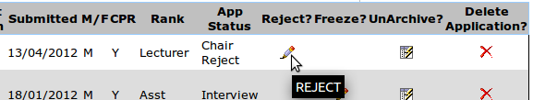

Note: To go back to “View Archived Files” at any time in the rejection process, click on the circular red button located at the bottom of the form:

(Part 1)
Upon selecting the rejection button, the page will redirect to “Rejection Letter (step 1)”. The text box adjacent to “Applicant Name” displays the name which the applicant will be addressed by. The text box below corresponds to the position(s) the applicant is being rejected for. These fields may be edited by deleting the current text and populating the field with the appropriate information. To continue with the rejection, select REVIEW REJECTION LETTER.
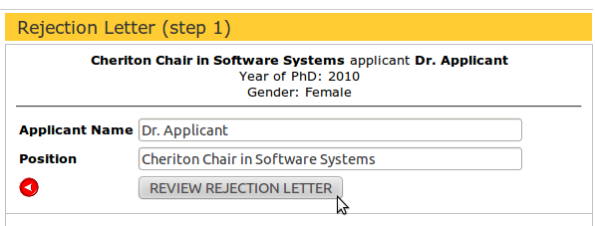

(Part 2)
The page will redirect to display the rejection letter; ensure the letter has been reviewed. If the letter contains any inaccurate information, do not send the letter. Rather, select the circular red button to redirect to Step 1.

The letter text may be editable, if the job has been configured to allow this (under “Job Management” in Section 4.1.3) If so, you may change the contents of the email that is sent by editing this text field.

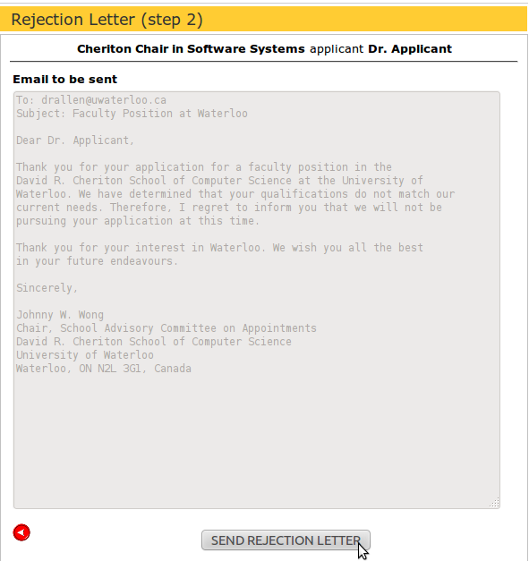

To complete the rejection process, select “SEND REJECTION LETTER”.

Provided no errors, a message reading “Candidate Application Rejected” will appear directly under the “View Archived Files” heading.

Note: The option to freeze, or un-archive, the application is no longer applicable.

Note: If an applicant applies to more than one position, it is sufficient to send only one rejection letter.

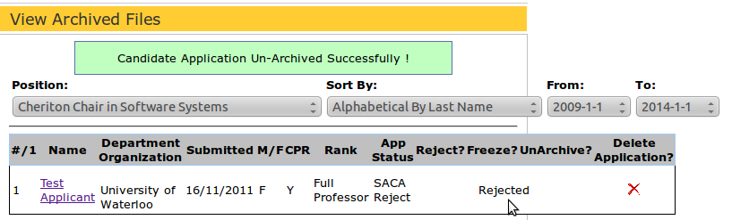

3.6.3 How to Freeze an Application
Before an application can be frozen, it must first be archived with the appropriate status (see Section 3.5.1: Overview, above). For more information on archiving, see Section 3.4: Archiving/Un-archiving an Application.

From the navigation menu on the left-hand side, select the “View Archived Files” tab. Locate the name of the applicant to be rejected. Under the column entitled “Freeze?”, click on the pencil icon.
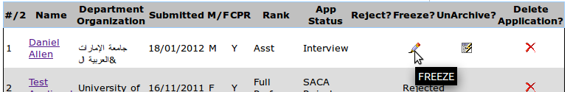

The page will redirect to display a message warning of what freezing an application entails. To continue with freezing the application, select “FREEZE APPLICATION” .
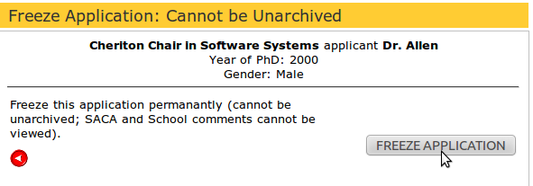

Provided no errors, a message reading “Candidate Application Frozen” will appear directly under the “View Archived Files” heading
Note: The option to reject, or un-archive, an application is no longer applicable.

3.7 Sorting Applicants within a Job
You can sort applicants by various criteria using the “Sort By:” function built into the “SACA Review” display.
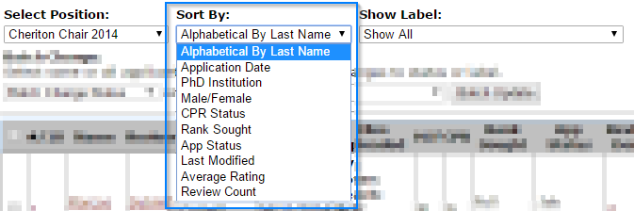
Simply click the option you want to sort by and the sort will be instantly applied to the table.

3.8 Downloading PDFs of Applicants
Sometimes there is a need to download applicant’s details and associated files for offline use. To do this you can use the “Download All PDFs” button on the “SACA Review” page. Clicking the button will download one PDF file with all of the applicants combined. The applicant summary, including their reference list/statuses are included, as well as all of their associated uploaded files.
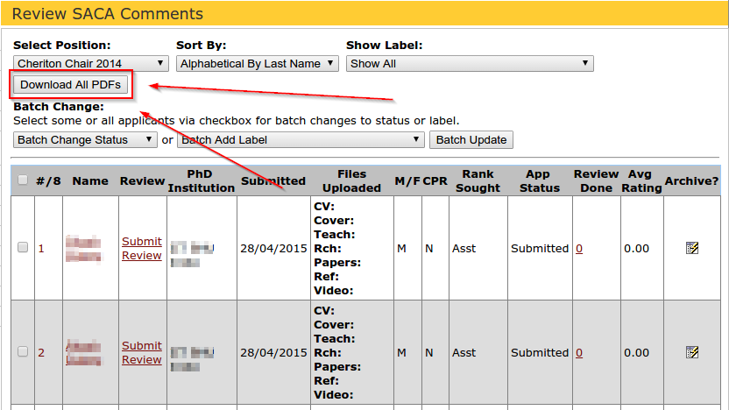

If you’d like to manually select a specific group of people to download PDFs of you can use the checkboxes to manually check off each person you’re interested in downloading a PDF for. Once you have selected all of the people you’d like to, you’ll notice that the “Download all PDFs” button is now changed to a “Download selected PDFs”. Click this new button and you’ll be given a single PDF file with all of the applicants you had selected.
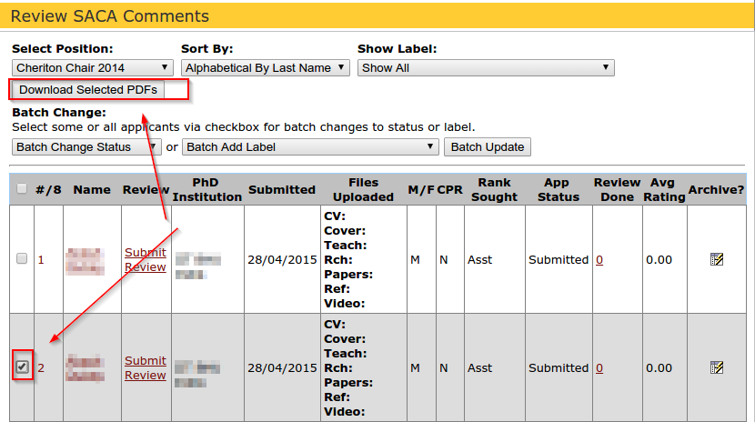

3.9 Viewing Unapplied
The left-hand menu “View Unapplied” will bring the chair to a page listing all people who have registered in the system but have not yet completed an application. To reiterate, when someone registers in the system, they are prompted with the following four steps:
STEP 1: Confirm Profile
STEP 2: Upload Application Files
STEP 3: Submit Application
STEP 4: Submit References
They have not completed their application until they fulfill all 4 steps. The chair may review the list of unapplied candidates, and if any applicants appear to have completed step 2 (by supplying all required files), the chair may want to prompt the applicant to complete step 3 and submitting the application to one or more listed jobs. The applicant then will have to submit a list of references.

At the bottom of the page to View Unapplied, there is a button to “Delete unapplied.” This should be done after the recruiting cycle is complete, to clean out incomplete and stale applications. Note that once selected and confirmed, this cannot be undone.

Chair Admin Tasks
This section is intended to provide instructions for tasks frequently allocated to users with Chair Status.

4.1 Job Management

4.1.1 Required Fields Explained

4.1.1.2 Job Type
In the text field corresponding to Job Type, insert a short, clear job title that distinguishes the position.

4.1.1.3 Description
In the text field below, corresponding to Details, enter a more detailed description, if one is applicable. It is adequate for the description to contain the same information as the job type. However, if the Job Type does not include a date (YYYY), it is advisable to add this in the description.

4.1.1.4 Visibility
If you want the job to be visible to applicants, select the “Public” option. If the job is to be hidden from applicants, but still visible to SACA and faculty, select the “Hidden” option. If SACA and faculty no longer should see the job, but it’s not yet time to delete it permanently, select the “Archived” option. Note that if you set a job to “Archived”, all applications to the job will automatically be marked “Archived” as well. If you reset the job to “Hidden” or “Public”, the applications will not be reset to their un-archived status.

4.1.1.5 Custom Rejection Letter
Selecting “Yes” for this option will open up a textbox allowing you to create a custom rejection letter to use for this specific job. The textbox is automatically filled with the default letter which gives you a starting point. This option is used if rejection letters should have a different signature, for example for lecturer hiring.

4.1.1.6 Editable Rejection Letter
If “Yes” is selected, the rejection letter may be edited on a case-by-case basis. If “No” is selected then either the default letter or the custom letter (from 4.1.1.5) will be used.

4.1.1.7 Show Labels to Regular Faculty
If “Yes” is selected than the members of the “school” role will be able to view candidates (but not comment) before they hit the “Interview” stage. The “school” role will be able to view applicants in the “Short List” status, as well as the normal “Interview” state. However “school” members will only be able to leave their reviews on applicants who are in the “Interview” stage. The option to comment is hidden in the other stages.
If “No” is selected for the job, then the applicants will only appear in the “school review” when they are in the “Interview” and “Job Offered” stages and nothing else.

4.1.2 Adding a New Job
From the navigation menu on the left-hand side, select the “Job Management” tab. From the Job Management page, select the icon corresponding to New Job
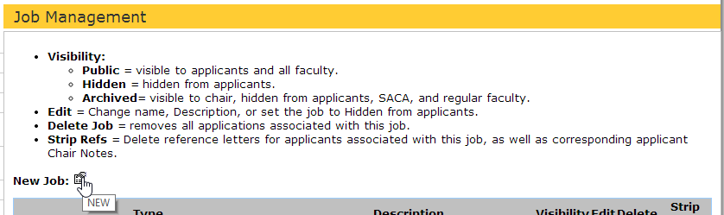

Once each field contains the appropriate information (see section 4.1.1: Required Fields Explained), select SAVE to save the new job.

Note 1: These fields can be edited at any time. See section below.
Note 2: While adding a new job to go back to the Job Management page and discard edits, select the circular red button in the lower left corner
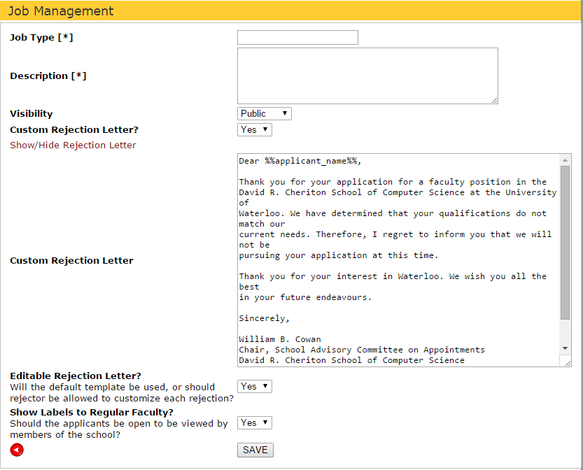

When you are finished adding a new job, provided there are no errors, the page will momentarily redirect to display the following message.
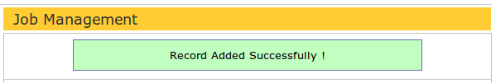

The page will redirect to the table displaying all job listings; the new job should appear this table.

4.1.3 Editing an Existing Job
To edit any of the five fields associated with a job (Job Type, Description, Visibility, Custom Rejection Letter, and Editable Rejection Letter), select the Job Management tab from the navigation menu on the left-hand side. Locate the position of interest from the table of listed positions. In the column corresponding to Edit, select the pencil icon in the cell.

Make any required changes then select SAVE. See Section 4.1.1 above for descriptions of the fields.

Note: To cancel without saving and return to previous page, click on the circular red button to the left of SAVE.

Provided no errors, the page will momentarily redirect to display the following message.

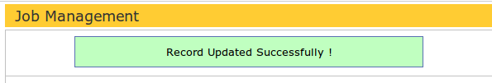

The page will redirect to the table displaying all job listings; the updates corresponding to the position will be displayed in this table.

4.1.4 Deleting an Existing Position
When a job cycle is completed, and any relevant statistics about the job have been collected for the School, the position, and all applications associated with it should be deleted. It must be deleted for privacy reasons after one year’s time after the job listing has been closed. For more information on Waterloo records retention policies, follow (Ctrl + click) one of the links below.
Records Management: http://uwaterloo.ca/records-management/records-classification-and-retention-schedule/human-resources
Records Storage and Disposal: http://uwaterloo.ca/records-management/records-storage-and-disposal
To delete a position, select the “Job Management” tab from the navigation menu on the left-hand side. Locate the job to be deleted. Under the column entitled “Delete”, click the icon in the cell.

The page will redirect from “Job Management” to a page entitled “Delete Job”.

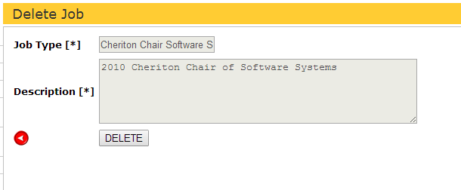

To go back to the Job Management page without deleting the job, click on the circular red button adjacent to DELETE.

To confirm the deletion, select DELETE. Provided no errors occurred, the page will momentarily redirect to display the message below.

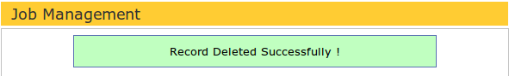

The job will no longer be displayed in the table of listed jobs. Additionally, all associated applications are deleted and cannot be recovered without system administrator assistance to access backups.

If an applicant has other job applications in the system, their .pdf files are not deleted, because the files are associated with the other job(s) as well. But if the applicant does not have other applications, their .pdfs are deleted along with the job they applied for. Their login will continue to work, but they will need to re-upload up-to-date application files the next time they apply.

4.1.5 Stripping References for an Existing Position
After an interview cycle, but before the year of data retention is up, we may want to strip all references from a position. This is done at the chair’s prerogative; it has not been done in recent years. Choosing this will allow job applicants to apply to the next year’s jobs and have a “clean slate” of references. Otherwise, applicants will see last year’s references, which they may delete themselves if they want new reference letters, or leave as-is if they prefer.

To strip references, under the column entitled “Strip Refs”, click the icon in the cell.

4.2 Generating Summary Reports

4.2.1 Overview
Summary reports contain statistical data on all applicants currently in the recruitment process. Reports are required by the University of Waterloo and Statistics Canada, to ensure the faculty recruitment is unbiased and offers equal opportunity of success to each applicant.

4.2.2 Viewing Summary Statistics
To view the summary reports, select the “Report” tab from the navigation menu on the left-hand side.
For convenience, you may wish to narrow your search by certain specifications.

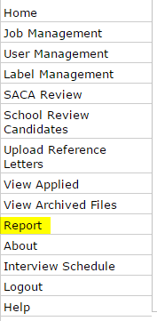

For statistics on a certain job, select the position of interest from the drop down menu entitled “Position”. If applicable, the search may be further narrowed by specifying gender (male/female) and Visa status (Canadian Permanent Resident (CPR) or Visa) of applicants displayed. The example below specifies a list of male, CPR applicants for a Health Informatics position.

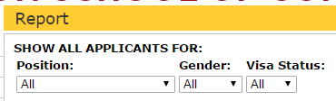

To view statistics between a specified period of time, select the desired date range (YYYY-MM-DD) from the drop down menu, starting from “From:” and ending at “To:” The example below specifies a list of applicants from the first of January, 2009 to the first of September, 2010.

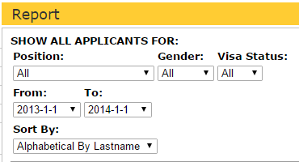

If you would like to sort by Application Date you can do this by changing the “Sort By:” box to “Application Date”

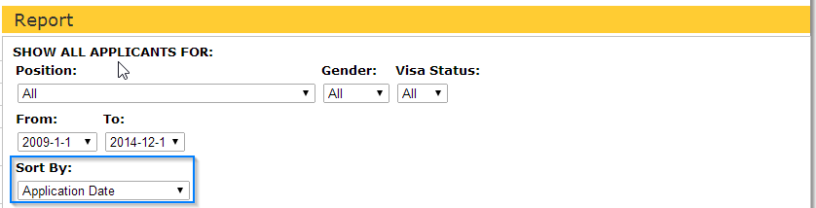

  - Reference Letters
Applicants are asked to provide at least three references, with their email addresses. For each email supplied, the system will email a reference letter request, which includes instructions to either upload a letter or decline to submit a letter.

If a reference uploads or declines, the applicant’s references view will update to acknowledge this status. See 4.3.4 Viewing Reference Letters for details about the statuses as visible by SACA.

Before the reference responds, the applicant’s references view will show “Awaiting Upload” to indicate that the reference has not yet responded.

If a reference submits a reference letter, the applicant’s view will indicate the letter was uploaded. An applicant cannot see the contents of the reference letters, but they may delete reference letter requests and submitted reference letters. In all cases, if a reference is deleted, the system has no further record of that reference letter request.

A reference may replace their reference letter by following the same URL they previously used to submit the reference.

Typically, a reference will upload and replace their own letter. Sometimes a reference may ask a system Chair to upload, replace or delete it on their behalf.

Reference letters should not be replaced out of concern for lack of space; there is no limit on the number of reference letters an applicant can have.

If an applicant has previously applied for a job, they may ask the Chair whether they can re-use their previous year’s log-in. The answer is yes; they may want to update any of their files and they may want to delete last year’s references and then re-ask their references for updated letters.

4.3.1 Adding a Reference Letter
From the navigation menu on the left-hand side, select “Upload Reference Letters”. From the first drop down menu corresponding to “Select Applicant”, select the title of the candidate of interest has applied to. From the menu below, select the name of the applicant.

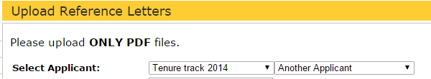

In the text field corresponding to “Reference Email Address”, enter the email address of the reference on whose behalf you are uploading.

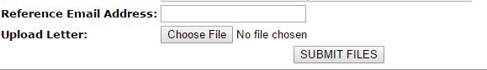

To upload an updated reference, click the “Browse...” button corresponding to “Upload Letter”.

Select the reference letter to be uploaded. Ensure that the uploaded file is in PDF format only! Any other format will not be uploaded, and will result in an error message. Select SUBMIT.

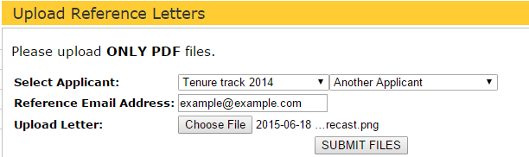

Once the PDF file has been uploaded, a message alerting that the letter was successfully added should appear beneath the heading. The newly uploaded reference will appear as a link in the Uploaded Letters section, named in the following fashion <reference email>_<year of upload>.

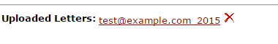

To view the letter, follow the link.

4.3.2 Deleting a Reference Letter
From the navigation menu on the left-hand side, select “Upload Reference Letters”. From the first drop down menu corresponding to “Select Applicant”, select the title of the job the candidate of interest has applied to. In the drop down box below, select the name of the applicant.

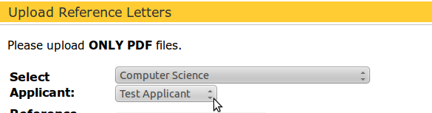

The section below, entitled “Uploaded Letters”, will display any references associated with the selected position and applicant. Locate the reference letter to be deleted.

For convenience reference letters are named in the following fashion.
<reference email>_<year of upload>

For completeness, it may be helpful to follow the link and ensure the correct letter has been selected.

To delete a letter, click on the red X icon directly adjacent to the letter to be deleted.
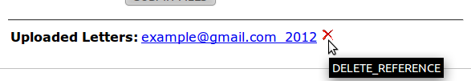

Provided no errors, a message alerting that the letter was successfully deleted should appear beneath the heading.

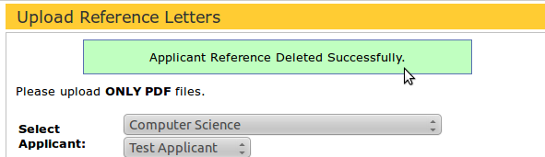

4.3.3 Replacing a Reference Letter
From the left-hand side navigation menu, select the tab entitled “Upload Reference Letters”. In the first drop down corresponding to “Select Applicant”, select the job which the candidate of interest applied to. In the drop down menu below, select the name of the applicant.

All uploaded reference letters corresponding to the chosen applicant will appear under the heading “Uploaded Letters”. The reference whose letter you wish to replace will appear under this section.

To replace the letter, first delete the current letter by clicking on the “X” adjacent to the file name.

Provided there are no errors, a message alerting that the letter was successfully deleted should appear beneath the heading.

To upload an updated reference, click the “Browse...” button corresponding to “Upload Letter”.

Select the reference letter to be uploaded. Ensure that the uploaded file is in PDF format only! Any other format will not be uploaded, and will result in an error message. Select SUBMIT.
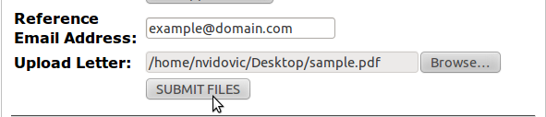

Once the PDF file has been uploaded, a message alerting that the letter was successfully added should appear beneath the heading. The newly uploaded reference will appear as a link in the Uploaded References section.
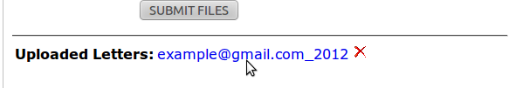

4.3.4 Viewing Reference Letters
From the left-hand side validation menu, select “View Applied”. From the table of applicants, select the name of the applicant of interest. Under the heading “Reference Letters”, a chart displaying the email address and status of each reference will appear. The three possible statuses are described below.

Status | Description
Awaiting Upload | The applicant has listed the reference, but the references has not responded to the invitation to upload yet.
Uploaded | The reference has uploaded a letter in behalf of the applicant. Click on the “Uploaded” link to view the letter in PDF format.
Declined | The reference has responded to the applicant's invitation to upload with a declination. All references are given an option to decline.

4.3.5 Stripping all References for an Existing Position
The chair may delete all references associated with a position, after the interview cycle is over. See 4.1.5 Stripping References for an Existing Position

User Management

5.1 Navigating the User List

5.1.1 Overview
To access the User Management application, select the “User Management” tab from the menu on the left-hand side.
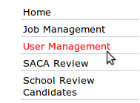
The User Management tab allows adding, updating, and disabling users of the faculty recruiting system. The users are subdivided according to their privileges.

5.1.2 User Categories
i) Chair: SACA Chair, updated yearly on July 1st.
ii) SACA members: Faculty committee members and student representatives, updated yearly on July 1st.
iii) School View: All faculty in the school, updated whenever new faculty are hired.
iv) Disabled Users: Users who are not allowed to access the system should be disabled. This includes, but is not limited to, retired faculty and former SACA student representatives.
Note: Disabling does not delete a user’s past posts; it only limits the user’s view.

5.2 Editing Users

5.2.1 Updating a User’s Privilege (to Chair/SACA/School/Disabled)
From the user list, select the user you wish to edit by left-clicking on the name

The edit user page will display the user’s first and last name as part of the heading.
To user’s current privilege will be preselected in the drop-down menu adjacent to the “Privilege” heading. Select the updated privilege from the drop down menu (for information on selecting an appropriate privilege, see “User Categories”)
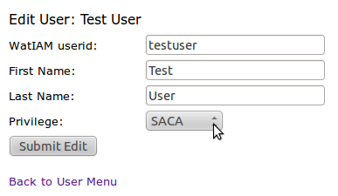

If the user was updated, the page will redirect to the User List. A message will appear directly under the “User List” heading:
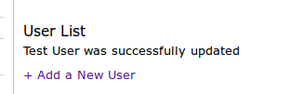

If the user update failed, the page will not redirect. A detailed error message will appear directly underneath the selected user’s name.
Ensure that the updated fields are appropriately formatted and no fields are left empty.

Note 1: Submitting a user update multiple times will result in an error message reading “There was no edit to apply”; selecting “Submit Edit” once is sufficient.

Note 2: Usernames are unique. Attempting to edit a username to one that already exists in the directory will result in an error message specifying so:
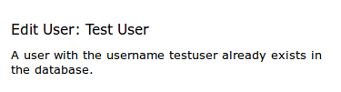

5.2.2 Updating First and Last Name Fields
From the user list, select the user you wish to edit by left-clicking on the name
The edit user page will display the user’s first and last name as part of the heading

To update the user’s name, first delete the current text in the field.
Enter the updated name into the blank field(s) corresponding to “First Name” and “Last Name”. Click the “Submit Edit” button.
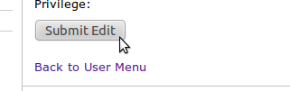

If the user was updated, the page will redirect to the User List. A message will appear directly under the “User List” heading.

If the user update failed, the page will not redirect. A detailed error message will appear directly underneath the selected user’s name. Ensure that the updated fields are appropriately formatted and no fields are left empty.
Note 1: Submitting a user update multiple times will result in the error message “There were no edit to apply”; selecting “Submit Edit” once is sufficient.

Note 2: Usernames are unique. Attempting to edit a username to one that already exists in the directory will result in an error message specifying so:

5.2.3 Updating the WatIAM Userid
From the user list, select the user you wish to edit by left-clicking on the name
The edit user page will display the user’s first and last name as part of the heading.
To update a username (synonymous with WatIAM userid, nexus id, uwdir, etc), first delete the current text in the field. Enter the updated name into the blank field(s) corresponding to “WatIAM userid”. Click the “Submit Edit” button.

If the user was updated, the page will redirect to the User List. A message reading “[The user’s name] was successfully updated” will appear directly under the “User List” heading.
If the user update failed, the page will not redirect. A detailed error message will appear directly underneath the selected user’s name.
Ensure that the updated fields are appropriately formatted and no fields are left empty.

Note 1: Submitting a user update multiple times will result in an error message reading “There was no edit to apply”; selecting “Submit Edit” once is sufficient.

Note 2: Usernames are unique. Attempting to edit a username to one that already exists in the directory will result in an error message specifying so:

5.2.4 Disabling a User
For information on what a “Disabled User” status entails, see “User Categories, section 5.1.2)
From the user list, select the user you wish to disable right-clicking on the name

to disable a user, select the “Disable User” option from the drop-down menu adjacent to the Privilege heading. Selecting this option will send an alert, select “OK” if you wish to continue (“Cancel” otherwise), then “Submit Edit”.
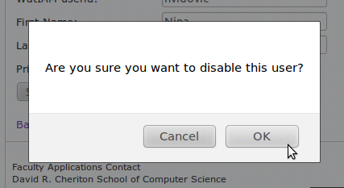

If the user was updated, the page will redirect to the User List. A message reading “[The user’s name] was successfully updated” will appear directly under the “User List” heading.
If the user update failed, the page will not redirect. A detailed error message will appear directly underneath the selected user’s name.

Ensure that the updated fields are appropriately formatted and no fields are left empty.
Note that submitting a user update multiple times will result in an error message reading “There was no edit to apply”; selecting “Submit Edit” once is sufficient.

Likewise, note that usernames are unique. Attempting to edit a username to one that already exists in the directory will result in an error message specifying so (see example below).

5.3 Adding Users

5.3.1 Overview of Field Names
Users are added when new faculty arrive, new SACA student representatives are nominated or a new SACA chair is chosen. See Section 5.2.1 “Updating a User’s Privilege” if you wish to update the status of Chair or a SACA Member.

To add a new user, the following fields must be submitted
i) WatIAM userid*: User’s username, typically a hybrid of the user’s first, middle, and last names. (Synonymous with uwdir,
nexus id, and other variations on username)
ii) First Name: The user’s given name, in full. If middle names are
applicable, they may be entered here.
iii) Last Name: The user’s family name, in full.
iv) Privilege: See “User Categories”, Section 5.1.2: User Categories for information on
selecting the appropriate privilege

Note: Text containing special characters (i.e., characters not included in the English alphabet) in this field will not be recognized and will result in an error message.

5.3.2 Adding Users: Chair/ SACA/ School/ Disabled Member
From the user list, click on “Add a New User”
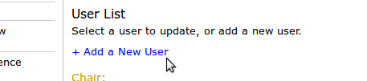

Under the heading “Create a New User”, input the appropriate information in the corresponding headings (see Section 5.3.1: Overview of Field Names).

To add a new member, select the appropriate user privilege (Chair/SACA/School/Disabled) from the drop down menu. For more information on what each privilege entails, see “User Categories” (see Section 5.1.2: Updating a User's Privilege).
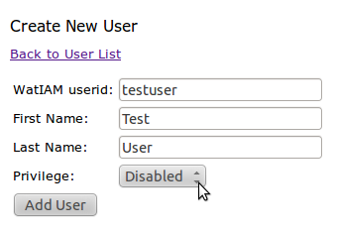

If the addition succeeded, the page will redirect to “User List”. A message reading “[The user’s name] was successfully added” will appear directly under the heading. The newly added user should appear under the appropriate privilege, sorted alphabetically by last name
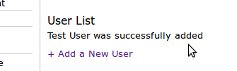

Note 1: Failure to input information in each field will result in an error message specifying which field(s) was/were left empty.
Note 2: Usernames are unique. Attempting to add a user with a username that already exists in the directory will result in an error message specifying so (see example below).
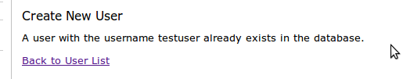

Miscellaneous Questions on…

6.1 Accessing the Website: How do I…

6.1.1 Validate my username and password?
You may need to activate your account. Follow the URL below for more information.
https://watiam.uwaterloo.ca/idm/user/login.jsp

Otherwise, contact Daniel Allen (information below) to ensure you have proper permissions.
Daniel Allen, CSCF
Phone extension x35448 Office: DC2621 email: drallen@cs.uwaterloo.ca

6.1.2 Log in?
Open a web browser* and enter the following URL:
https://cs.uwaterloo.ca/faculty-recruiting/

From the login page, enter your 8 character WatIAM userid in the text field corresponding to “Username” and your associated password in the text filed for “Password”.

If you cannot log in, see section above on validating username and password (see Section 6.1.1: How do I... Validate my username and password?)

6.1.3 Log Out?
There are three ways to log out, outlined below.
- From the navigation menu on the left-hand side, select “Logout” tab (should be the last option).
- Close the browser. After 5 minutes, the site will automatically log you out. However, this is not secure on computers with multiple users; in such cases, logging out manually is the best option.
- Remain inactive for 60+minutes. The site will automatically log you out. However, this may be a security risk if the site is accessed from a computer with multiple users; in such cases, logging out manually is the best option.

6.1.4 Change my view to be SACA/Admin/School?
Exclusively, Chair users have the ability to view the website with alternative privileges. From the navigation menu on the left-hand side, select “Home”. From the scroll down menu located near the bottom of the form, select the desired view. The available menus on the left-hand side will change to reflect the new view.

6.2 Job Management: How do I…

6.2.1 Hide Jobs from Applicants?
From the navigation menu, select the “Job Management” tab.
If creating a new job, select “New Job”, then select “Hidden” from the drop down menu corresponding to “Visibility”. Once all the fields are populated, click “SAVE” to save the new job.

If editing an existing job, locate the job from the table of listed positions. Select edit, then select “Hidden” from the drop down menu corresponding to “Visibility”. Click “SAVE” to save the update.

For more information, see Section 4.1:Job Management.

6.2.2 Restore a Deleted Job?
For security reasons, it is not possible to restore any files and applications associated with a deleted job, without substantial work by system administrators to restore the data. Use the archive option if you plan to need the job again shortly, but do not want to completely delete it.

6.2.3 Add/Edit/Delete a Job?
See Section 4.1: Job Management.

6.3 User Management: How do I…

6.3.1 Check that the user was added/edited/deleted?
If a user has been successfully added /edited /deleted a message reading “[User’s name] was successfully updated!” will appear beneath the page heading. The update should also be reflected in the User List.

Note that users cannot be deleted; only disabled. Disabling denies the user website access, but ensures that the user’s comments remain available.

6.3.2 Add/Edit/Delete Users?
For information on how to edit or delete (disable) a user, please see section 5.2 Editing Users.
For information on how to add a user, see Section 5.3: Adding Users.

6.3.3 Categorize Users?
Users are categorized according to their access privileges. In the User List, users are sorted into four categories: Chair, SACA, School and Disabled. For more information on what each privilege entails, see Section 5.1.2: User Categories.

6.3.4 Recover a Disabled (Deleted) User?
Since users are never completely deleted, they do not need to be recovered. To re-enable a disabled user, select the user’s name from the User List. From the “Edit User” page, update the privilege section from “Disabled” to the appropriate privilege. For more information on what each privilege entails, see Section 5.1.2: User Categories.

6.4 Reference Letters: How do I…

6.4.1 Sort applicants?
From the page entitled “Upload Reference Letter”, locate the two drop down boxes adjacent to “Select Applicant:” From the first menu, select the name of the position of interest. From the drop down menu directly beneath, select the name of the candidate of interest. If no particular candidate is of interest, select “All Candidates.”

6.4.2 Know when I’ve reached the limit?
There is no limit on the number of reference letters pertaining to a certain candidate. Note, however, that one reference letter may be uploaded at a time. To upload more reference letters, simply repeat the process.

6.4.3 Check if References have been uploaded?
From the Upload Reference Letters page, select the position and/or name of the applicant of interest from the drop down menus pertaining to “Select Applicant”. If reference letters exist, they will be listed in PDF file format beneath “Uploaded References”, near the bottom of the form.

6.4.4 Delete a Reference Letter?
For more information, see Section 4.3.2: Deleting Reference Letters.

6.5 Archived Files: How do I…

6.5.1 Sort applicants?
From the View Archived Files page, locate the drop down menu corresponding to “Sort By:” Select the order by which applicants are to be sorted. The default sorting method is “Alphabetical by Last Name”.

6.5.2 Access an applicant’s contact information?
From the tabulated list of archived applicants, select the name of the applicant of interest. The page will redirect to display the applicant’s summary. All available contact information pertaining to the applicant can be found here.

6.5.3 Delete an Application?
From the tabulated list of archived applications, locate the application of interest. Under the column heading “Delete Application?” select the red “X” icon in the cell. The page will redirect to display basic information, including files, comments and background information, on the candidate. To continue with the delete, select “DELETE”.

Be aware that once deleted, applications cannot be recovered for security reasons.

6.5.4 Interpret the column headings?
Below is a short explanation of each column heading.

Column Heading | Interpretation
Name | The applicant’s full name
Submitted? | A response to whether any files exist on the applicant; yes (Y) or no (N)
M/F | The applicant’s gender; male (M) or female (F)
Rank | The position sought by the applicant: Full Professor, Associate Professor, Assistant Professor, or Lecturer
App. Status | The status in the application path at which time the file application was archived.
Reject? | An option to reject an applicant. For more information on rejecting an applicant, see Section 3.5.2: Rejecting an Application.
Freeze? | An option to freeze an applicant. For more information on freezing applications, see Section 3.5.3: How to Freeze an Application.
Un-archive? | An option to un-archive, or reactivate, the application. Please note that once an application has been frozen or rejected, it cannot be un-archived.
Delete Application? | An option to delete the application and all associated files. For more information, see Section 6.5.3: How do I... Delete an Application? Please note that once an application has been deleted, it cannot be restored.

6.6 Report Statistics: How do I…

6.6.1 Sort Reports?
See Section 4.2.2: Viewing Summary Statistics.

6.6.2 Know if an applicant has any uploaded files?
From the tabulated list of applicants, locate the applicant of interest. If any files pertaining to the applicant have been submitted, a Y (yes) will appear underneath the column entitled “Files?” If no files have been submitted, an N (no) will appear in the cell.

6.6.3 Interpret the column headings?
Below is a short description of each column heading.

Column Name | Interpretation
Position | The job title of the position(s) the applicant applied for
Name | The applicant’s full name
Institution | If applicable, the institution at which the candidate obtained a doctorate
Rank | The position sought by the applicant: Full Professor, Associate Professor, Assistant Professor, or Lecturer
CPR | In response to whether the candidate is a Canadian Permanent Resident: Y (yes) or N (no)
Resp. Date | Date candidate submitted application
Decision | The current status of the application; may not necessarily be an end status.
Files? | In response to whether any files have been submitted on the applicant: Y (yes) or N (no).

6.6.3 Know if a potential applicant has registered but not applied for any jobs?
From any page, select “View Unappplied” to see the registrants in the system who have not applied to any jobs in the system. Under normal procedures, registrants who applied in the previous job cycle will not appear in this list (because last year’s job will still be in the system). However, if they did not apply in last year’s job cycle, but did in a previous year to that, because their application has been purged they will appear in this list of Unapplied.

