The
Cheriton School of Computer Science:
SACA System V.2.4.
User Guide
--------
APPLICANT VIEW

Last revised: Aug 25, 2011

Table of Contents

Introduction i
System Specifications ii
1.1 The Log-In Screen 1
1.2 Creating Account 1
1.3 Logging In 3
1.4 Logging Out 4
1.5 Confirm Your Profile 4
1.5.1 Changing Your Password 5
1.6 Uploading Your Documents 5
1.7 Submitting Your Application 6
1.8 Application Received 7
Troubleshooting 8
Index 11

Introduction

This manual is designed to aid users as they progress through the Cheriton School of Computer Science online faculty application. The manual is divided into three sections: system specifications, system functionality, and troubleshooting.

System Specifications
The SACA system has been tested on Firefox 3.6, Firefox 4, Safari 5 and Internet Explorer 8.
Firefox has been tested on:
- Linux (Ubuntu 10.04, 10.10 & 11.04)
- Macintosh (OS 10.5 and 10.6)
- Windows (XP and 7)
Internet Explorer has been tested on:
- Windows (XP and 7)
Safari has been tested on:
- Macintosh (OS 10.5 and 10.6)

The Log-In Screen
To apply to an open position at the Cheriton School of Computer Science open your web browser and enter: http://www.cs.uwaterloo.ca/faculty-recruiting/
Press Enter.
This will take you to a login screen.
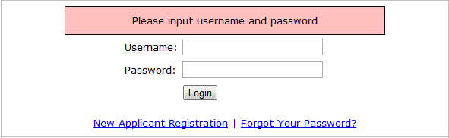
If you are not a registered user see 1.2 Creating an Account.

Creating Account

Click on New Applicant Registration under the login section.

You will be directed to the CSFAS (Computer Science Faculty Application System) Applicant Registration page. You must enter all information requested on this page to continue.

Select your title from the drop down menu.
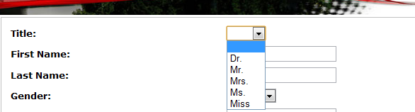

Enter your first name for the First Name field and last name for the Last Name field.

Next choose your gender from the provided drop down menu.
Enter the e-mail address at which you would like to be contacted in the corresponding Email field.
Create username for the Username field and a password for the Password field.
Ensure that they are at least 8 characters in length.
Confirm your password by re-entering it in the Confirm Password field.
*NOTE* See 1.4 Confirm Your Profile to change your password.
Enter an appropriate answer in the What Is Your Mother’s First Name field. This information would be used if you forget your password.
Enter your preferred telephone number to be contacted in the Telephone field.
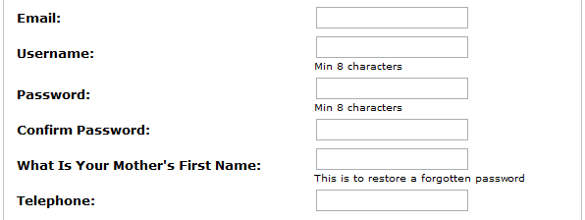
From the drop down menu select Yes if Canadian or Permanent Resident of Canada and No if you are not.
Enter your educational status
Enter the year when you completed your PhD. If you are still in progress, enter the year you expect to complete your PhD.
If PhD is not applicable enter “N/A”.
If applicable enter the name of the institution you received or will receive your PhD. Otherwise, enter “N/A”.
Select the rank/position that you wish to apply for from the drop down menu.
Your CSFAS Applicant Registration page should have no unfilled fields. Ensure that all entries are correct.

A sample of a completed registration page is below.
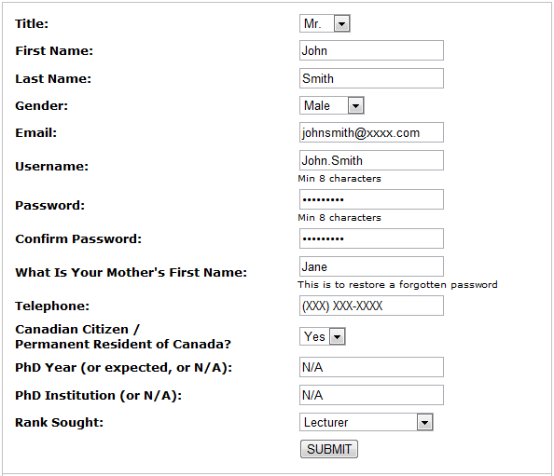d: johnsmith
Once you are sure your information has been entered correctly, click Submit.
You will see this message:
You will then be automatically redirected to the CSFAS (Computer Science Faculty Application System) page to login. To login, see 1.3 Logging In.

Logging In
To apply to an open position, open your web browser and enter: http://www.cs.uwaterloo.ca/faculty-recruiting/
Press Enter.
This will bring you to the Computer Science Faculty Application (CSFAS) page.
To login, enter your username for the Username field and your password for the Password field.
Click Login.
If you are brought to the CSFAS welcome page as shown below, you have successfully logged in.
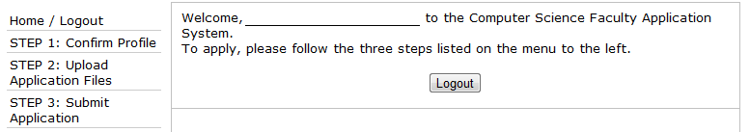
To logout, see Logging Out.

Logging Out
To logout:
Click Home/Logout on the left of the screen.
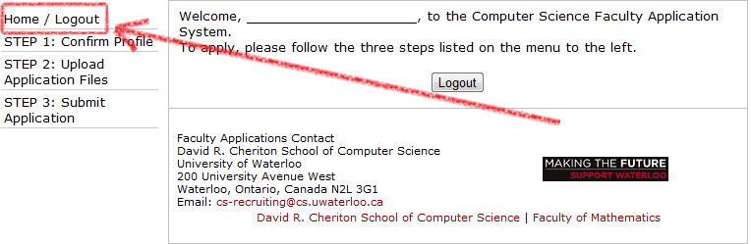
Click Logout.
*NOTE* You will be automatically signed out if you are logged in and inactive for 60 minutes.

Confirm Your Profile
Here you will be able review and update your profile.
*NOTE* You will not be able to change your username.
Click STEP 1: Confirm Profile from the left-hand menu.
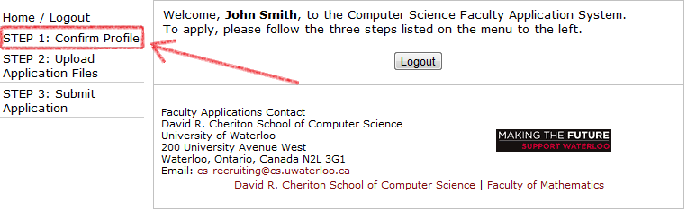

Changing Your Password
To change your password, enter your new one in the Password field and re-enter it in the Confirm Password field.
Click Confirm.
You will see this message:
You will then be automatically redirected to STEP 2.

Uploading Your Documents
To upload a document click on STEP 2: Upload Application Files from the left-hand menu.
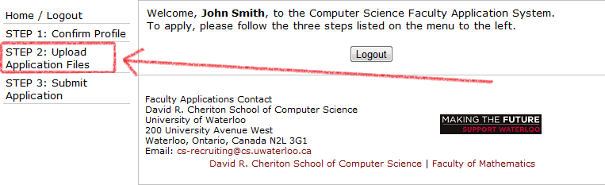
*NOTE* All fields marked with “*” are mandatory.
To upload a file, complete the following:
Click Browse next to the type of file you wish to upload. For example: If you want to upload your CV click Browse located next to CV in the list.

A search window will pop-up. Locate and select your .PDF file and click Open.
The file name will appear next to the Browse button.
Repeat steps 1 and 2 to upload your CV, teaching statement, research statement, and publications.
Once all documents are uploaded, click Upload Files.
Links to your documents will appear at the bottom of the page. The system will automatically rename your files.
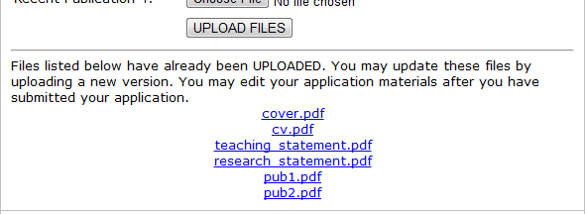
To view your file(s), click on each link and your document(s) will open in a separate tab. Do this to ensure that your documents have been uploaded correctly and are ready to submit.

Submitting Your Application
Click STEP 3: Submit Application.
You will be taken to the Submit Application page.
You will be able to submit an application for the open position(s).
To submit your application for a position, click Submit beside the listed position.
Next you will be automatically taken to the Confirmation page. Click Confirm to submit.
The following message will appear:
If you do not see the above message your file(s) were not successfully uploaded. Check that they are “.PDF” files with at most 10MB in size.
You will then automatically be redirected to the Submit Application page. If your application has been successfully submitted you will notice the “Action” column of the position for which you applied should now read, “APPLIED” as seen below.
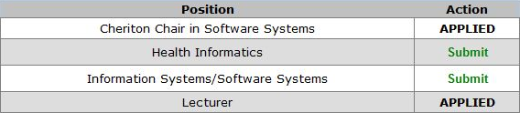
You have now completed the application process.

Application Received
This stage is when your application is under review.
Click STEP 3: Submit Application.
If you are brought to a page entitled, Application Received, your application is now under review.
This mean that you can no longer update the documents you have uploaded.
You may, however, update your profile by clicking, STEP 1: Confirm Profile.

Troubleshooting

Accessing the Webpage

PROBLEM | POSSIBLE SOLUTION(S)
I see an error page when I try to access the Faculty Application System webpage. | - Ensure the URL entered is identical to: http://www.cs.uwaterloo.ca/faculty-recruiting/  - The website may be experiencing difficulties, try again later.  - Refresh the page.  - Attempt to access the webpage using a different browser.
I have used the correct URL when trying to access the website but continue to see an error page. | - Ensure that your computer is connected to the internet.  - Contact your network provider.  - Contact cs-recruiting@cs.uwaterloo.ca

My Profile

PROBLEM | POSSIBLE SOLUTION(S)
How can I delete my profile? | Contact cs-recruiting@cs.uwaterloo.ca
Can I change the information in my profile once submitted? | Yes. Sign into your account using your username and password. Click Confirm Profile in the left hand menu and you will be brought to a page in which you can update your information. Once you are finished, click Confirm.

My Username and Password

PROBLEM | POSSIBLE SOLUTION(S)
How long does my username need to be? | At least eight characters.
How do I change my username? | You cannot change your username once it is created. To acquire a new username you will need to create a new account.
I’ve forgotten my username. | Contact cs-recruiting@cs.uwaterloo.ca to reset your username.
I’ve forgotten my password. | Go to http://www.cs.uwaterloo.ca/faculty-recruiting/.  Click on “Forgot Your Password?”  Enter your username in the text box next to Username.  Enter your email address in the text box next to Email.  Enter the answer to the security question, What Is Your Mother’s First Name.  Click the RETRIEVE PASSWORD button.  A temporary password will be sent by email with further instructions.
I’ve forgotten my password and do not have/remember the needed information to retrieve it. | Contact cs-recruiting@cs.uwaterloo.ca to reset your password.
How long does my password need to be? | At least eight characters.
How do I change my password? | Log in to your profile with your username and password.  Click STEP 1: Confirm Profile in the left-hand side menu. Enter your new password in the Password field and re-enter it in the Confirm Password field.

Document Uploads

PROBLEM | POSSIBLE SOLUTION(S)
When uploading documents my files no longer carry my file names. | The system automatically changes the file names for its own recording purposes.
How can I delete a document? | You cannot delete a document, but you can Upload a new document in its place. The new document will replace the older one (which will be deleted).
My files will not upload, there is a brief message that appears and I am redirected to the upload page before I can read it. | Your file is not a ".PDF" or it is an empty file. Please ensure that your files are complete and saved as “.PDF” before they are uploaded.
I am trying to access my uploaded files however I am brought to the Application Received page. Is it too late to change my documents now? | Yes. Please contact cs-recruiting@cs.uwaterloo.ca.
When test viewing an uploaded document, a new tab is opened but my information is not displayed. | This is because the file you have uploaded does not meet the uploading standards: The file must be less than or equal to 10MB in size and the file must be a ".PDF" file.

Submitting my Application

PROBLEM | POSSIBLE SOLUTION(S)
When I click submit to apply to a position, I am taken to the Upload Application Files page. | You are required to upload your CV, teaching statement and research statement in order to submit an application for the position you are applying for. Please upload your CV, teaching statement and research statement as “.PDF”  files and continue your application.

Withdrawing my Application

PROBLEM | POSSIBLE SOLUTION(S)
I’ve applied for a job but would like to undo the submission. How can I undo the submission? | Contact cs-recruiting@cs.uwaterloo.ca.
I’ve applied to the wrong position. How can I revoke the application? | Please submit your application for the correct position.  To withdraw your application from the wrong position, contact cs-recruiting@cs.uwaterloo.ca.
I’ve accepted a position elsewhere. How can I withdraw my application here? | Contact cs-recruiting@cs.uwaterloo.ca.

Reference Letters

PROBLEM | POSSIBLE SOLUTION(S)
How can I submit my reference letters? | Contact your referee(s) and tell them to use one of the following methods:  - E-mail: cs-recruiting@cs.uwaterloo.ca  - Post: Chair, Advisory Committee on Appointments  David R. Cheriton School of Computer Science  200 University Avenue West  University of Waterloo  Waterloo, Ontario, Canada N2L 3G1
Will my application be processed even if I do not have reference letters? | No, you must have referees send your references via one of the following methods:  - E-mail: cs-recruiting@cs.uwaterloo.ca  - Post: Chair, Advisory Committee on Appointments  David R. Cheriton School of Computer Science  200 University Avenue West  University of Waterloo  Waterloo, Ontario, Canada N2L 3G1  *NOTE* If you are applying for Cheriton Chair, these two steps do not apply.

Index

account, 9
applicant view, 1, 4, 5, 6, 7
application, i, 7, 10, 11
completed registration page, 3
confirm, 2, 5, 7, 9, 10
creating account, 1
csfas applicant registration, 1, 3
cv, 6
documents, 6, 7, 10
educational status, 2
error, 9
login, 1, 4
logout, 4
menu, 1, 2, 3, 5, 6, 9
message, 3, 5, 7
name, 1, 3, 6
network, 9
password, 2, 4, 5, 9, 10
profile, 2, 5, 9, 10
publications, 6
referees, 11
registered user, 1
research statement, 6
review, 5
search window, 6
signed out, 5
submit application, 7
submitted, 7, 9
teaching statement, 6
upload files, 6
username, 2, 4, 5, 9

